Ephemeral Graphic Traces

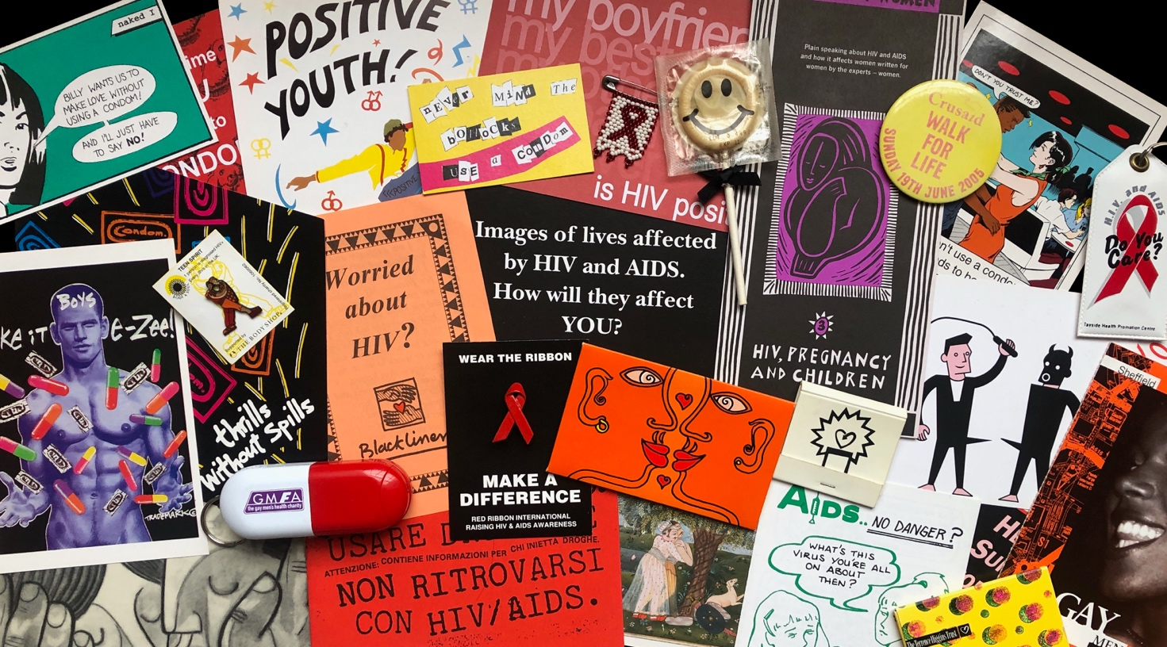

Caption: Items from Graphic Communication: A UK HIV and AIDS Design Archive www.hivgraphiccommunication.com

Each country and community has a different AIDS experience, which is reflected through the imagery produced or adapted for small, localised campaigns and communications, including flyers, fundraising leaflets, condom packaging, t-shirts, badges, and so on, the whole host of material that makes up the epidemic’s ‘visual ephemera’.

‘Ephemera’ has been defined as “something of no lasting significance”, but the opposite can be true if we make the effort to preserve and examine these materials in depth. A more helpful definition is “items that were originally expected to have only short-term usefulness”, acknowledging the original purpose and intention as significant.

The archivist Lucy Brownson observes that ephemeral materials often challenge conventional archival practices due to their transient and ambiguous status:

“Despite persistent professional anxieties and archival omissions, ephemeral archives often constitute a powerful source for counter-histories of a given institution, community, movement, or era. Such materials are imbued with the specific social and emotional textures of their creators’ lives and accordingly, they require a level of familiarity with their context in order to produce useful, meaningful layers of interpretation.”

Brownson’s insight applies just as much to graphic print ephemera as personal papers. It is crucially important that the wealth of visual materials originally produced around HIV and AIDS, made to inform and encourage behaviour change, to campaign and raise funds, and to show solidarity, are included as part of the epidemic’s visual culture legacy. Such materials had a variety of makers, whether produced by volunteers, professional designers, activists and artists, or as often, a combination of these. Works of art may be preserved in collections and catalogues, and more familiar mass media campaigns may be discussed in cultural studies seminars, but often overlooked ephemeral graphic traces can be used to unlock new stories in different ways. For example, artefacts prompt memories and act as discussion points, adding value to the gathering of oral histories and providing details of historical context for critical analysis.

Many items were created to respond to a very specific time, place or behaviour. These intentionally ephemeral materials could be highly localised or burn bright for a limited period around a particular collective or community. The following examples are all taken from the collection of a UK HIV and AIDS graphic archive, and together show the different histories and textures of experience that emerge when ephemera is given the attention and analysis it deserves. The items in the archive were never intended to endure. Like much graphic design, they were created to serve a specific purpose at a particular moment. Yet this transience does not diminish their value as cultural artefacts. On the contrary, they merit preservation alongside artworks precisely because they inadvertently capture and embody distinct moments in the narrative of AIDS.

**************

Design ephemera is seen as worthy of retention either because of its documentary value or because of its ability to illustrate some aspect of contemporary design, or the uses to which design is put in everyday life.
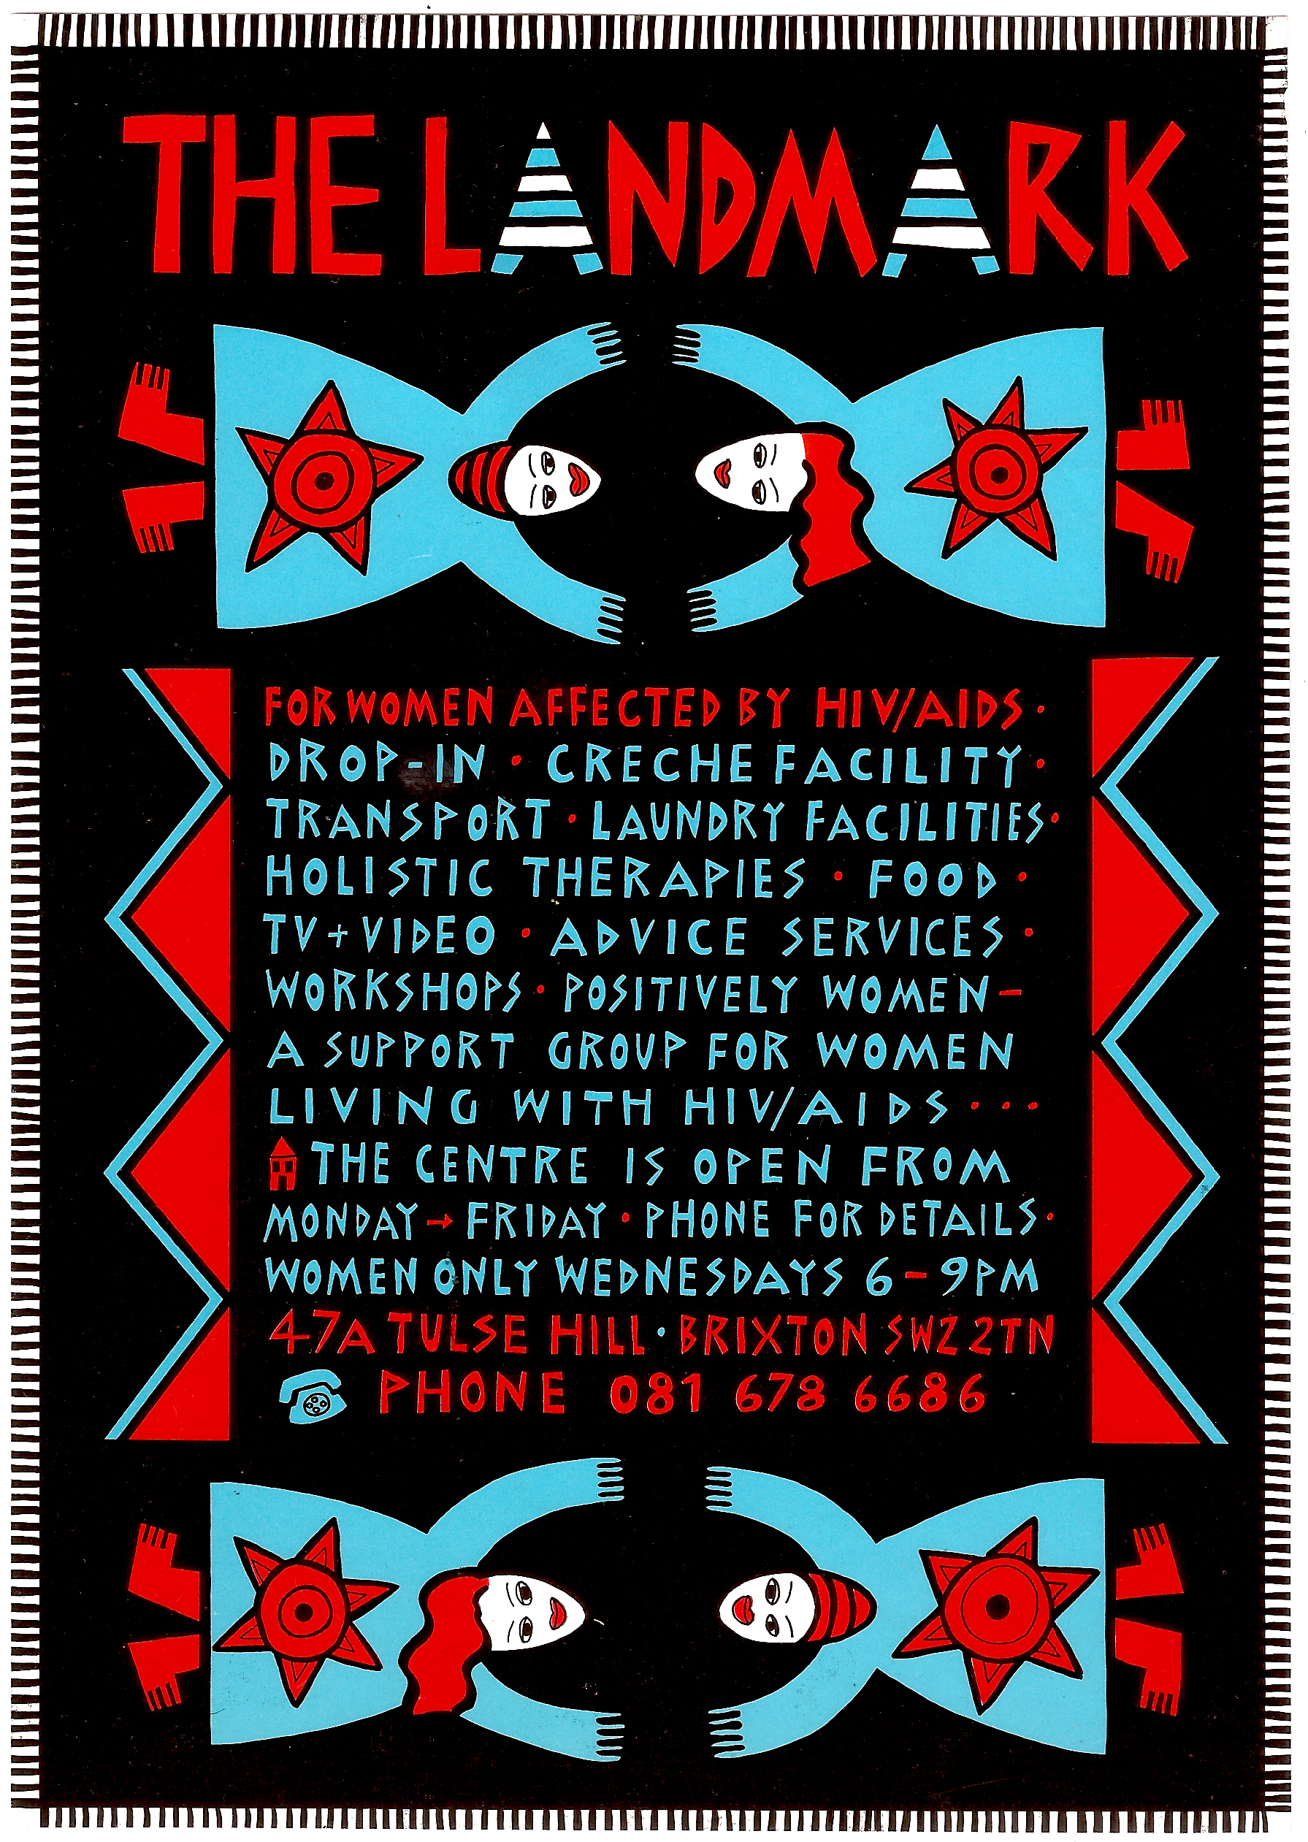
– Criteria for Ephemera Collections, Victoria and Albert Museum
Caption: Positively Women, Landmark flyer (c.1991). A6: 84x60mm. Design and illustration: Jane Shepherd. Image used courtesy of Jane Shepherd and Positively UK.

Artists, photographers and professional graphic designers – HIV positive, negative or untested – all volunteered their skills during the period of ‘AIDS Crisis Culture’. This resulted in a wide variety of styles and visual interpretations, many of which better reflected the audiences they were intended to reach than the more ‘official’ public campaigns. The work of designer and illustrator Jane Shepherd has its roots in advocacy for women and girls’ rights, as she states on her website; “through good design I can amplify the work of women living with HIV.” In this example for The Landmark, a day centre in South London that provided practical and emotional support for people living with HIV, the design feels upbeat and friendly, suggesting a non-specific cultural diversity. The hand drawn typography, patterning and ‘folk’ style illustrations are eye-catching and suggest an inclusive and welcoming space. The list of everyday services and the female focus of this particular flyer adds to the sense of place-making, a domesticity created by the fringed rug or shawl that contains the layout. The information provided also indicates the sharing of spaces by different communities and cooperation between the groups for whom the facility was a valuable part of their everyday lives.

**************

“Ephemera are printed artifacts, usually less substantial than books, which, though intended for specific limited purposes or events, are kept by libraries and archives because they contain continuing research value, notably for the study of popular culture”.
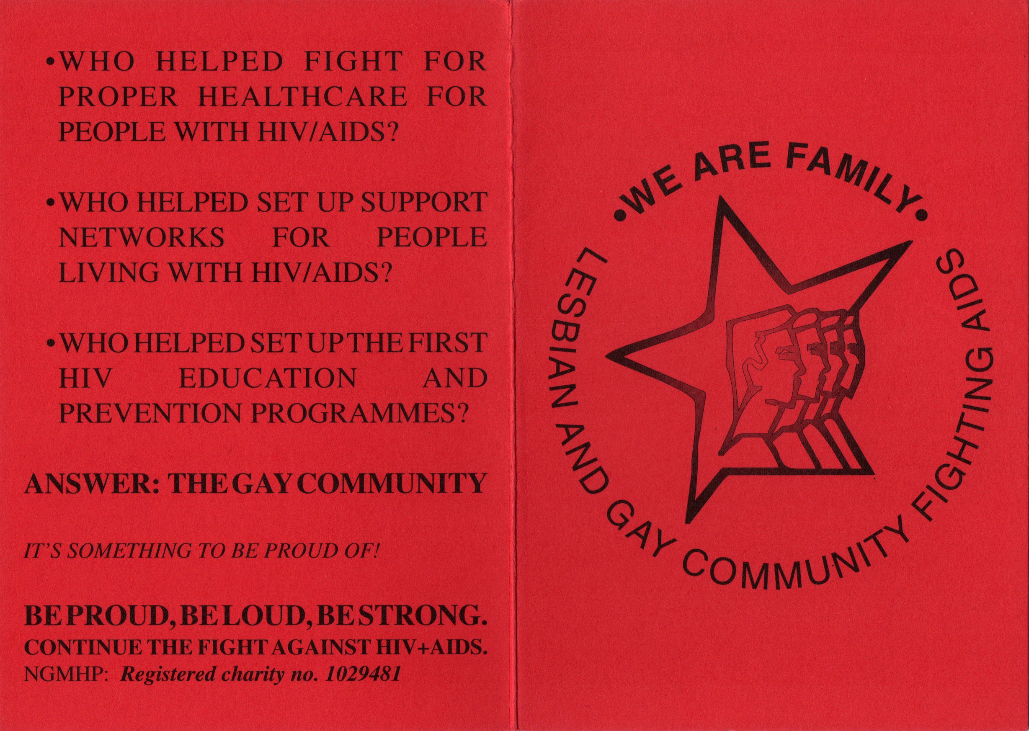
– Timothy Young, ‘Evidence: toward a library definition of ephemera’ (2003)
Caption: Norwich Gay Men’s Health Project, card (c.1994). Folded to A6: 84x60mm, back and front shown. Concept: Will Nutland, Design: Scott van Looy. Image used courtesy of Will Nutland.

As small independent organisations continued their fight against AIDS into the 90s, it was important for them to maintain solidarity and build resilience with their supporters. This card from Norwich Gay Men’s Health Project (NGMHP) celebrated the achievements of the gay community in a simple, low-cost folded card, printed on one side – leaving the inside blank with the potential for adding a personalised message or acting as a folder for other postcards in the same print run.

The design references a style of pop constructivism that had become the visual language of left culture during the 80s in the UK. Soviet communist propaganda art had been adopted as an aesthetic reference point by style magazines such as The Face and anti-racist demonstration graphics. The pop group, Communards, used stylised heads – united and facing forward into the future – as their band logo. Their profiles sported the signature ‘buzz-cut’ of lead singer Jimmy Somerville, part of the ‘queer uniform’ (for both men and women) of the time, aligning with his public persona as an openly gay, socialist, and politically active artist. The heads in the NGMHP design were deliberately androgynous and the text acknowledges lesbians as an equal part of the ‘family’ united in HIV and AIDS activism. Another pop group with strong gay cultural associations was Frankie Goes to Hollywood, who re-released and remixed a number of their earlier singles in 1993, repackaged in a strong red and black constructivist style and also featuring a dynamic asymmetric star as a recurring image. The NGMHP card design alludes to the sense of resistance and strength through the comradeship forged by a volunteer army. Other organisations such as Gay Men Fighting AIDS had an influence on regional activist groups such as NGMHP in referencing the military tropes used within gay culture to illustrate their literal battle for survival, expressed with pride in promoting “the safest weapons, condoms & lube”. These types of ephemera were tapping into the gay community’s popular cultural icons and archetypes to create contemporary communications that their audiences would recognise and identify with.

**************

“It’s nice to know why something was made, by whom and for what purpose – we can’t fully understand the thing without such knowledge – but we’re free to use things (and ideas) differently. We decide what’s significant and how; we decide what it all means”.
– Chris Cardinal, ‘Ephemera in Archives’ (2016)

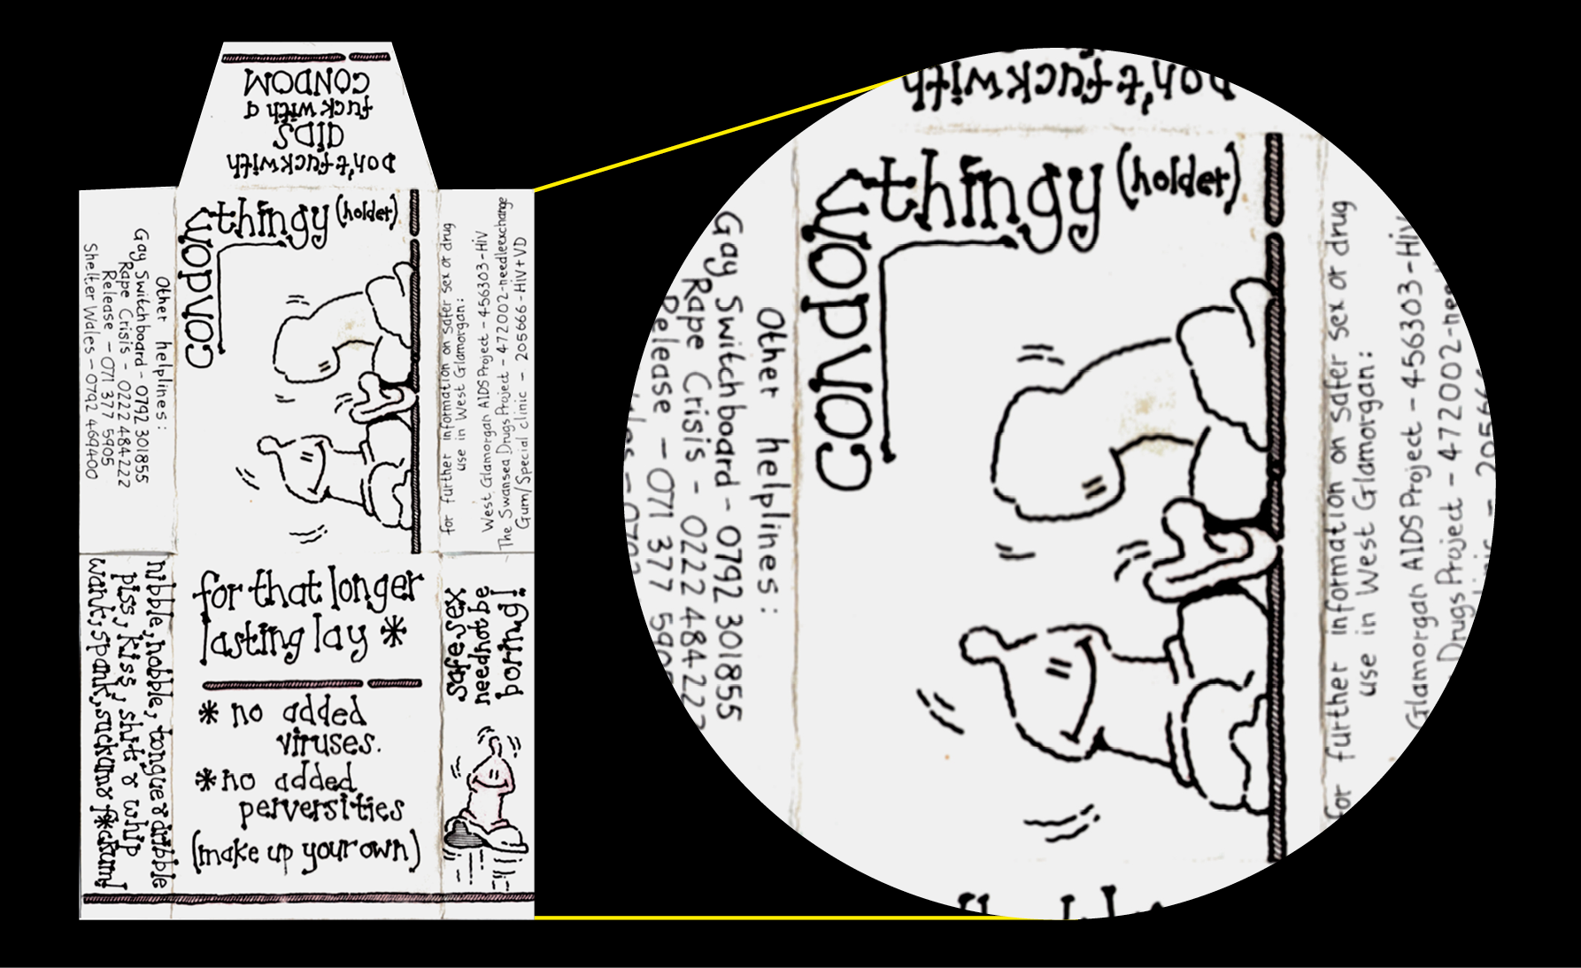
Lack of provenance for a piece of ephemera demands closer inspection to identify the date, creator or copyright ownership. The archivist becomes a forensic detective looking for clues. Whilst frustrating, lack of provenance can also become a gift, leaving space for speculation or fictionalisation and inviting fresh creativity as to how we might use and respond to materials. Even one small item could be the starting point for an exhibition.
Caption: West Glamorgan AIDS Project condom packaging (c.mid 90s). Assembled size: 84x60mm.

The handmade aesthetic of this Welsh condom pack has a friendly and inclusive tone of voice. It is non-threatening, not particularly audience specific and has the look and feel of something locally made and assembled. The second colour, a pale pink, is quite faded. The illustrations were probably taken from another source as the information about local resources has been added separately in a different handwriting. The sharing of resources and imagery between organisations and even countries was common practice at the time. The packet template is very simple, it does not include tolerances and extra allowance for flaps and bleed that a professional printer would use, so was probably assembled by hand. Making up and stuffing condom packs was often a communal group activity that strengthened volunteer connections.

**************

“If archivists regarded ephemera not as inconsequential and short-lived documents, but, for example, as commercial art, advertising or marketing tools, then the objects become more than ephemera. Rather they reflect the growing societal trends of visual awareness and the power of marketing”.
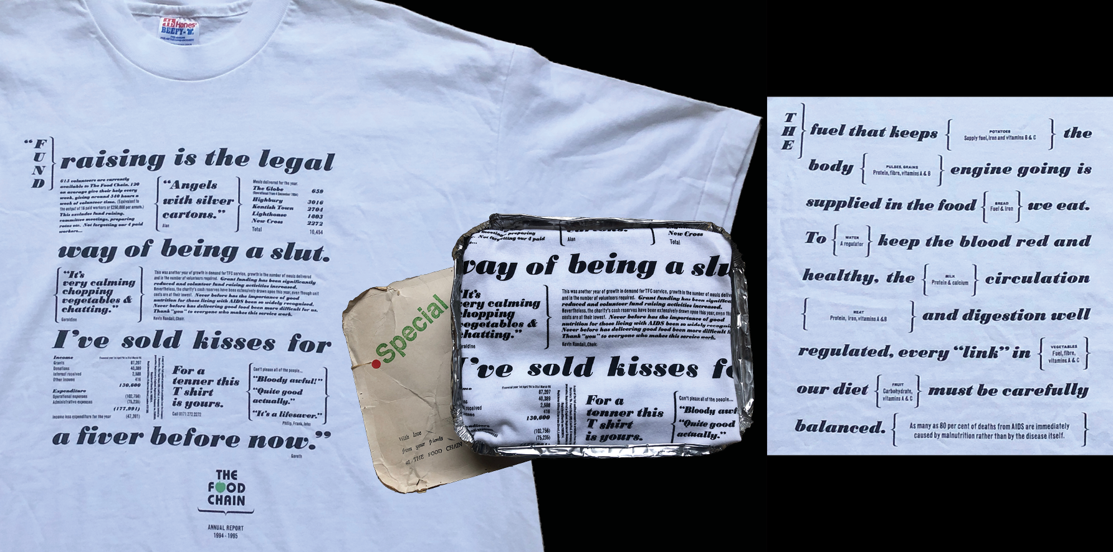
– Jim Burant, ‘Ephemera, Archives, and Another View of History’ (1995)
Caption: The Food Chain Annual Report 1994-1995 (1995). T-shirt, printed front and back, mailed out in a foil food container. Image used courtesy of The Food Chain.

With many AIDS service organisations (ASOs) in the UK increasingly competing for funding in the 1990s, alongside reliance on charities to continue providing vital resources for people living with HIV, formerly grassroots voluntary groups had to professionalise and find creative ways to raise awareness of their work in order to survive. Inspired by American organisations, The Food Chain has been delivering nutritious meals to people living with HIV in London since 1989, but 1996 was the last year that its funding would come from statutory sources. In 1995, The Food Chain printed a summary of their annual report onto t-shirts which could be purchased and were mailed out in foil takeaway food containers, the same as used to deliver meals to HIV positive service users. The text included personal testimonies and information about the importance of good nutrition, alongside statistics and financial facts about the organisation. The typographic layout and hierarchy were carefully considered, using the typeface Bodoni Black Italic as a main design feature. The t-shirt exemplifies the increasingly sophisticated and innovative methods that some ASOs were employing and demonstrates how the use of graphic design helped elevate their marketing communications.

**************

“An item of ephemera is essentially a form of time capsule, a crystallization of another time and place”.
– Brian Durrans, ‘A Present from the Present’ (1990)

Gay Men Fighting AIDS’ (GMFA) ‘Out’ campaign ran from 1997 with the aim “to support and encourage HIV positive gay men who want to be open about their status to potential sexual partners.” This represents a very particular period in the epidemic. Anti-retroviral drug treatments were available from the UK National Health Service and proving to be effective, but evidence for low viral load reducing HIV transmission, leading to the U=U message, did not become available until the early 2000s. In the meantime, more HIV positive men were experiencing improved health, having sex and navigating discussions about their status. The campaign was launched with postcards and teaser adverts in the gay press introducing the ‘+ve’ logo (“Say it, hear it, it means ‘positive’”).

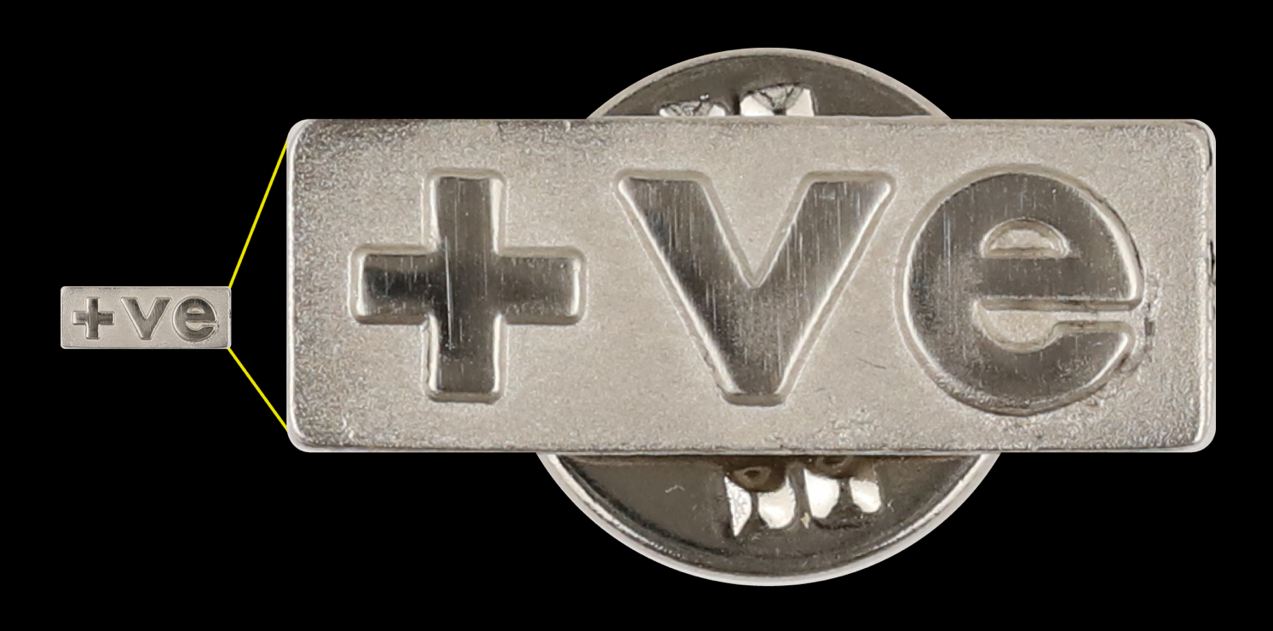
Caption: GMFA lapel badge (1999). 8x20mm, metal. Image used courtesy of LGBT HERO.

“We wanted the tone of the campaign to be positive – upbeat, supportive, assertive – and we chose a symbol which directly refers to the apparent irony of that word when used to indicate HIV status. The symbol also takes its cue from the success of the gay community in ‘reclaiming’ the pink triangle – originally a symbol of prejudice – as a sign of strength and pride.”

GMFA recognised that the messaging had to address several complicated issues, explaining that the intention was not to tell men that they should be open about their status, but to provide advice about ways to do so and create a more supportive atmosphere around disclosure within the gay community. A series of different executions, ads and formats were therefore employed in their attempt to ‘smash the closet of the nineties’. In a time before gay dating apps, it was felt that a discreet way of informing potential partners of HIV status might be useful. These lapel pins came mounted on a postcard bearing the message ‘It’s not a label – it’s just a badge’. Whilst the campaign served as a useful talking point, it is not clear how many badges were actually distributed or worn and the U=U slogan eventually provided an even more compelling argument against HIV stigma.

**************

These five examples of graphic ephemera are a small representation of the thousands of items produced over the course of the AIDS epidemic in the UK, and of the innovative use of design, illustration, photography and other formats that have been employed to carry messaging about HIV prevention, support and service promotion. The reach of these individual items, compared with national campaigns, was limited, yet this is exactly why their histories are worth examining. As Simon Watney argued in 1990, “we should be very cautious of evaluating any aspect of cultural politics against over-simplified criteria of effectiveness, as if the size of the audience were always the most important factor. […] In all such matters, strategy is everything.”

Small organisations trying to reach their specific audiences often used graphic design and print media in new and effective ways. In the present moment, looking back on the diverse history of HIV and AIDS as the epidemic continues to unfold, we need to create opportunities and platforms to enable cross fertilisation between visual material archives, oral histories and cultural communities, opening up a space for micro-storytelling to bear witness and make use of graphic ephemera to reveal universal truths.

https://www.merriam-webster.com/dictionary/ephemera
https://dchistory.libguides.com/c.php?g=1190637&p=8777339
Lucy Brownson (2023). ‘Odds, ends, and archival exclusion: ephemeral archives and counter-history in the English country house’, Archives and Records, 44:3, 308-329, DOI: 10.1080/23257962.2023.2248017
Criteria employed for ephemera collections by institutions such as the Victoria & Albert Museum, London.
1980s-1990s; the era of significant activism and cultural production in response to the crisis, according to Ted Kerr’s identification of six AIDS epochs, in ‘We Are Having This Conversation Now: The Times of AIDS Cultural Production’ Duke University Press (2022).
https://www.janeshepherd.com/about/
Timothy Young (2003). ‘Evidence: toward a library definition of ephemera’. RBM: A Journal of Rare Books, Manuscripts, and Cultural Heritage. 4. p.25.
The Face magazine, art directed by Neville Brody 1981-86. See also work by David King, graphic designer for City Limits magazine, Anti-Nazi League and Rock Against Racism.
Jimmy Somerville was an active member of ACT-UP and used his public platform to raise awareness and fundraise for AIDS related causes.
Lead singer, Holly Johnson, publicly shared his HIV positive status in 1993.
A London-based organisation established in 1992.
GMFA, ‘Conquer AIDS’ poster, 1994: https://digitalcollections.lib.rochester.edu/islandora/object/uraids:5571
Chris A. Cardinal Tales: The Blog of Special Collections and University Archives at Iowa State University. Ephemera in Archives, June 1, 2016. https://isuspecialcollections.wordpress.com/2016/06/01/ephemera-in-archives/
All reasonable efforts have been made to locate the copyright owners for this item. If you are the owner of this content and wish to have it removed or attributed differently, please contact the author.
Jim Burant. ‘Ephemera, Archives, and Another View of History’. Archivaria 40, October 1995. p.192.
The creator is unknown but was likely to have been a professional graphic designer.
Brian Durrans, ‘A Present from the Present’, The Ephemerist, June 1990. p.340.
Jeremy Canty. ‘Say It Loud’ in F***sheet (The Journal of Gay Men Fighting AIDS), May 1997. p.1.
Undetectable=Untransmissable
Canty. p.1.
Simon Watney, ‘Representing AIDS’ in Tessa Boffin & Simon Watney (eds), Ecstatic Antibodies: Resisting the AIDS Mythology, River’s Oram Press, p.188 (1990).

