Spaces and Places in Online Learning:

Perspectives from students and staff

Abstract

This paper is based on work carried out during the first six months of 2021, a year into the Covid-19 pandemic and a time by which the practices of online learning and teaching had become familiarized and – to some extent – even standardized in our institution, as in most others.

We are chiefly concerned here with the online teaching space as a social space: as an environment designed to give agency to staff and students and to facilitate interactions that adhibit learning and teaching. How suitable are the environments that we have created to achieving such outcomes? Is it reasonable to describe the environments in which we learn and teach online as ‘spaces’, using the same word (and in virtually the same sense) used to describe the familiar physical teaching spaces of bricks-and-mortar locations?

Our primary research involved bringing learners, teachers and digital specialists together within online learning spaces, and inviting the students present to represent their experiences of the virtual space, using simple analogue tools: coloured pens and paper. The results of these workshops form the basis for this paper. In using these analogue methods to capture responses to a digital environment, we planned to step away from habitual online behaviours, and capture personal and even emotional responses to digital experiences.

In our conclusion, we attempt to formulate some explanations for the emotionally-inflected nature of these representations of digital learning spaces. Using ideas from psychogeography, approaches taken from the study of place (Augé, 1995), social-actor theory (Emirbeyer and Mische, 1998) and pedagogic theory (Gourlay, 2014, 2021, Wenger-Trayner, 2014), we question the status of the online learning environment as a social space and its consequent impact on teaching and learning.

Keywords: digital; space; psychogeography; non-place; agency

(1) Introduction: Psychogeography in the online learning space
Psychogeography is the study of how geography affects human emotions (DeBord, 1981, p.5). The techniques of psychogeography, originally developed to study the effects of urban spaces on human emotions, have expanded to embrace ex-urban and – more recently – virtual spaces (see, for example, Bullingham and Vasconcelos (2013), Elias (2010), Sylaiou et al (2018), White and Le Cornu (2011)). As psychogeographer Luke Bennett has observed: ‘The affective relationship between the arrangement of things in space and the experience of place remains a central trope of psychogeographical account writing.’ (Bennett, 2015, p.70) If we accept that the online environment has an emotional effect on the individual, exactly as a physical environment, then psychogeography – when allied to parallel approaches and discourses – becomes a tool for investigating individual responses to online experiences, such as those encountered in learning.
In their influential paper of 2011, White and Le Cornu (building on Prensky, 2001) link the experience of the internet as a place (not a space) with the acquisition of a digital identity, to become – in their nomenclature – a ‘digital resident’. They suggest that place ‘is primarily a sense of being present with others. A sense of social presence’, thus grounding their distinction between digital visitors and residents in the social (and thus affective and emotional) dimension of individual online behaviours – and through employing a deeply-embedded geographical metaphor. .
Amy Elias (2010) goes further, explicitly linking the online learning space to the practices of psychogeography. She bases her argument on the work of DeBord, and cites examples taken from Second Life as literal instances of online dérive practice. Elias grounds her psychogeography in the experience of the human body in space, linking online experience with the physical technologies that support it, while noting that the internet ‘should be seen in very specific instances as an analogue to real urban space that provides new opportunities for detournement and dérive.’ (Elias, p.831-32).
Likewise, Sylaiou, Chountasi and Lagoudi (2018) discuss hybrid flâneur and internet mapping practices that blur the boundaries between online and offline psychogeography. Dzardanova, Kasapakis, Gavalas and Sylaiou (2021) conclude their study of power and student compliance with authority in immersive VR learning spaces by noting ‘the overall ability of a virtual setting to be as impactful, if not more, emotionally, and psychologically [as physical spaces].’

Using the tools of psychogeography to investigate virtual spaces subverts physical/virtual binary distinctions, while acknowledging the primacy of the body as the site of self and identity in both physical and digital spaces. Lesley Gourlay challenges the concept of the ‘idealized free-floating human subject’ (Gourlay, 2021, p.64), which she characterizes as the product of a neo-liberal vision of internet freedom, which discounts or disregards offline lived experience. Kinsley (2014) makes a similar point when he suggests that ‘in opposing “the virtual” and “the real” we either oppose technically mediated experience to other forms of experience, or we oppose our technical life to other, apparently “natural”, forms of existence’ (Kinsley, p. 15). Gourlay, rejecting the real/virtual binary, advocates moving ‘towards a more diverse, looser conception of engagement which takes in what is going on around the screen, as opposed to treating the screen as a narrow portal for a particular type of performance’ (Gourlay, 2021, p.70). This last quote sheds light on several of our own student drawings, which situate their internet connection and screen amongst the physical artefacts of daily life.

Students’ online learning identities – including their engagement with group learning and representations of the self within digital learning spaces – has been discussed, by (among others) Bullingham and Vasconcelos (2013), Byl et al. (2015), Crowther (2019), Dennis et al. (2020), Gordon (2014), Gourlay (2014), Gourlay, Littlejohn et al (2021), Gourlay et al (2021), Gourlay (2021), Hansson and Sjöberg (2018), Johnstone et al (2019), Savin-Baden et al (2015) and Shahabudin et al (2018). But the nature of these digital spaces themselves – in which such interactions occur – has been less acutely studied.

Online learning spaces have no front or back, and no empty seats. Most of the cues that spell out power and authority have apparently disappeared. Cameras can be switched off, thwarting the panoptic gaze. Visible body language can be completely absent. Yet it seems that a space has emerged behind our computer screens that reproduces the power relationships of the physical world.

The skeuomorphic designs of the early years of the personal computer must be part of the story. The Graphical User Interface (or GUI) of Apple computers was central to their success: the ‘home’ icons with pitched house-roofs in spaces where it never rains, the equipment of the office including folders, files and a waste bin, and the index finger cursor to command with – all these have played a part in transplanting preconceptions about space into the virtual spaces ‘behind’ our screens.
When we inhabit these online spaces as learners and teachers, their psychogeography can be construed as an absurd parody of the power relationships of the physical world. Panels within online rooms display participants in strict role-based hierarchies; participants can literally be muted, infantilizing them in the process – a situation which is exacerbated when permission to speak requires raising a (skeuomorphic) hand.
Behind this simulated familiarity is a void, where students’ sense of place can easily become dis-located. Our research has exposed or highlighted a split between those who conceptualize their bodies and their physical surroundings as an integral part of the online learning space depicted, while other participants convey the experience of an event taking place outside physical space and even time – Gourlay’s ‘idealized free-floating human subject’. It is noteworthy that neither of these positions implies a binary online/offline distinction: both are – in their different ways – attempts to make sense of the online and offline aspects of a single social experience.

- The research design
Students across our college (undergraduate and postgraduate) were invited to participate in a short series of open-access online workshops, which were entitled ‘The Psychogeography of Online Learning Spaces’. Interested members of staff were also invited. Using Blackboard Collaborate (the platform most widely used by our university), we asked participants to represent in analogue form the psychogeography of this learning space: to become online psychogeographers and to map their personal experiences. Two standalone one-hour workshops were offered, and a representative mix of undergraduate and postgraduates from a range of art and design disciplines participated. A third workshop drew a mix of learners, teachers and digital specialists. Attendance at the workshops averaged 11-12 participants. All participants gave consent to their words and images being used in future published research. The workshops were recorded.

Blackboard Collaborate has much of the same functionality as GoToMeeting, Teams, Zoom and other online conferencing tools. But Blackboard is arguably more hierarchical than platforms such as Zoom, which were originally conceived for use in conferencing and social situations. For example, users of Blackboard Collaborate must be assigned the role of Participant, Presenter or Moderator – with concomitant powers and privileges within the shared virtual space (Participants having the least, Moderators the most). As a gesture to promote a feeling of equality, all members of these psychogeographic workshops (students and staff) were given Moderator status on request.

After an opening introduction to the method and purpose of the workshops, the participatory exercises began with a request to portray the spatial and power relationships within the online classroom. Analogue drawing was used to depict and comment on the digital experience from a purposefully non-digital perspective. Conversations were held during the workshops around the intended meaning of the images. Thus, drawings could be influenced both by the discussion of the participant’s own work, and by the conversations around the output and input of others.

- Outline of results
The responses varied widely, but could be categorised broadly into two distinct types.

One type of illustration (discussed in section four) involved the depiction of the participants’ physical situation, seated in front of their computer screen. Such images involved a degree of literal representation – however stylised – and might also partially employ a non-literal symbolic language.

A quite different response to the exercise was to create a purely diagrammatic or symbolic representation of the entire space (or spaces) under consideration. These diagrammatic responses eliminate the juncture between physical and virtual spaces, as everything is rendered in the same formal language in a construct that intertwines and unifies the representation of virtual and physical experience. There were also participants who rendered the psychogeographic space holistically, but as one organised skeuomorphic image, symbol or complex visual metaphor.

Some depictions of this kind involve the projection of the participant into a landscape of the mind where commonsense notions of space and identity no longer apply. These hybrid depictions – rendering the virtual and physical world as one unified environment – are discussed in section five.

In section six, we attempt to draw some conclusions from the various ways in which online and physical spaces have been rendered in these workshops. We draw upon theories of psychogeography, place, skeuomorphism and social agency to suggest ways in which the historical development of the internet and its user interfaces have shaped both students’ and teachers’ ability to engage with the virtual spaces in which they teach and learn.

(4) Illustrating Appearances
The first group of illustrations attempt with varying degrees of literalness to depict what a participant might actually see – both on their own device and also in the physical space around them. These depictions are – naturally – freighted with symbolic overtones, but they proceed outwards from the immediate visual experience of the workshop, understanding the participant’s virtual space via its impact and influence on their own physical space.

A gateway into the virtual world

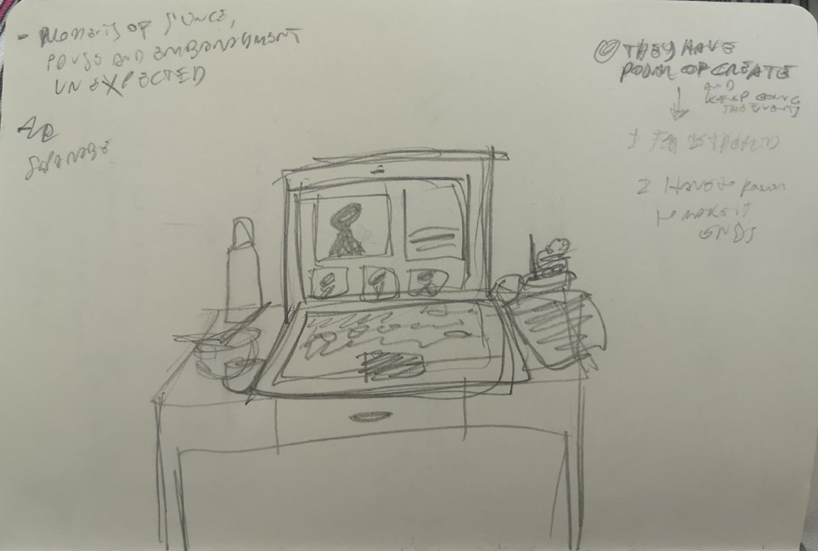
Figure 1
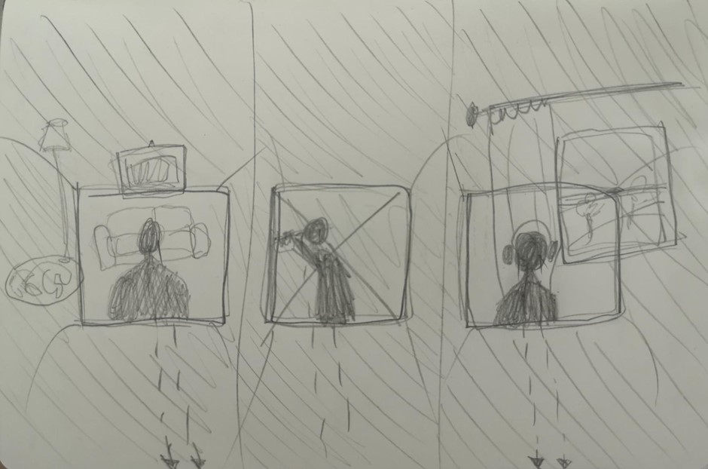

Figure 1a

This is a clear and literal rendition of the participant’s workspace: a desk, a computer screen, a mouse and the other paraphernalia (Figure 1). The computer screen becomes the window or gateway into the virtual world. The participant has shared their point of view and thus placed themselves within a psychogeographic domain that lies outside a shared learning environment, which is hinted at but not fully depicted. As the student commented: ‘I feel a detachment between me and the screen. I can turn off my mic and I can turn off my camera and what you are going to see is just my data and not myself. It’s like an avatar of me, not me.’ The icons – the talking heads – shown in the rectangle representing the screen are a literal transcription of what one sees during an online class. The sketch has faithfully captured how the talking heads are lined up by the software code, with the participant who is speaking given the largest space on the screen. In the online environment of Blackboard Collaborate power and authority (the power inherent in being the one who speaks) is automatically translated into increased screen-size.

This same participant’s second sketch – in response to a request to depict the power relationships in this virtual environment – has produced a multiplication of the basic situation: a line of three participants, all encased within the chassis of their computers (Figure 1a). The participant remains in their safe space, and the other attendees remain in their cells. As the student commented: ‘The reality continues behind this window [of the computer screen]… Power is in the people watching. Because I have the power to go out of the session and to make it end, I fell less responsibility to be part of it.’

Outside the shared environment 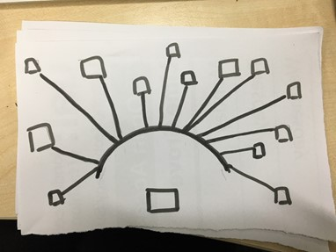
Figure 2

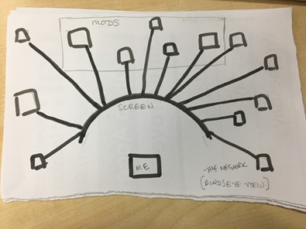
Figure 2a

Figure 2 represents a more stylised reading of the same perceived situation. This scene resembles a teacher facing a class (Figure 2), but in fact it is the participant (labelled ‘me’ in Figure 2a) who is isolated from the group and is seated in front of their screen.
But although ‘me’ sits outside the shared environment, this rendition affords a visualization of a shared space inside or behind the computer screen. And inside this shared space there is a network connecting the other participants. But the network is an elementary one, a ‘Bus’ network in which all devices join a central cable. Such networks are no longer favoured by IT administrators due to the high risk of failure and the low volume of network traffic they can carry. There is also hierarchy hinted at by the shorter or longer lines that connect the various individuals. Some are placed inside a rectangular space labelled ‘Mods’ (i.e. Moderators). These ‘Mods’ are grouped in a privileged central position. But there also seems to be a hierarchy of closeness to the screen (frequency or confidence in speaking?) that operates alongside the binary division of Moderators/others.

(5) Illustrating the online experience

A very different set of outcomes begin from a holistic depiction of the entire event, rather than as a portrayal of what an individual participant experiences.

Bubbles
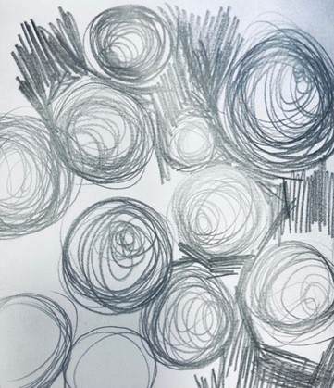
Figure 3
Figure 3 seems to position every member of the workshop on a basis of equality. There may be subtle distinctions of rank in these grey circular forms – which resemble searchlights perhaps – but any distinctions of role or importance appear secondary to the apparent similarity of all these elements. There do appear – on close inspection – to be certain fenced off areas (such as the top left or bottom right), and one could tentatively interpret these as the location of the workshop Moderators. Some of the circular forms are shaded, whilst others are barely more than outlines. But what these visual distinctions might represent in terms of power or agency within the online classroom is left undefined.

This participant has found a way to convey the sense of closeness and simultaneous isolation that online teaching events can provoke. This huddling implies a characteristic response to the agoraphobia that can be engendered by online spaces. Participants are tightly jammed together, yet appear to have no impact on each other: no interactions. There is a strong sense of a bounded self, existing within a constrained though largely unstructured space. The impression of lights shining into one’s eyes conveys the feelings of generalised anxiety that so many students report from their online learning experiences. As this student commented: ‘In the online learning space, people appear and disappear without leaving any trace.’

In discussion, this participant identified the forms as bubbles. Bubbles featured in numerous drawings throughout the series of workshops: they suggest a fleeting and precarious experience, the focus on a short-lived present that can characterize online experience (see Augé, 1995, below). Bubbles also determine what is inside and what is outside: they can be seen as protection. Bubbles became synonymous with protective isolation in the context of Covid-19, of being apart, and of being apart-together in a social bubble. Bubbles can offer physical and architectural security, as Sloterdijk notes: ‘They protect themselves from the terror of the bottomless, of the infinitely expanded space, through the utopian yet pragmatic erection of a global greenhouse intended to offer modern living in the open.’ (Sloterdijk, 2011, pp.21-22)

Hidden power
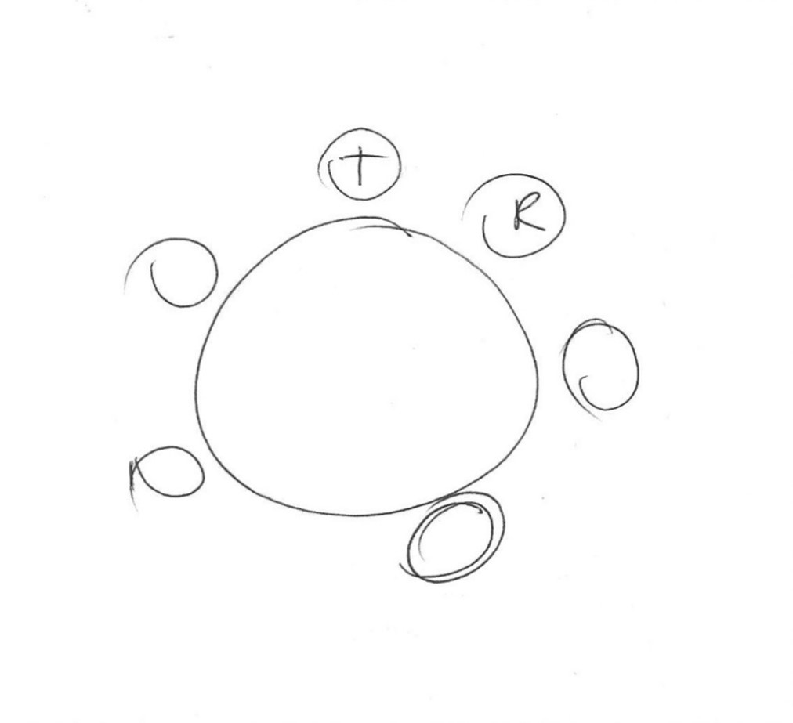
Figure 4

Figure 4 is diagrammatic or symbolic, representing the structure of the workshop holistically. The participant is reticent about their point of view: they seem to be both everywhere and nowhere within the space depicted. T

he participants are positioned at the circumference of what could be read as a round table. Yet there is the ghost of a hierarchy still visible, as one of the circles representing the members of the workshop is labelled ‘T’ and another ‘R’ (referencing the two researchers), demarcating them from their anonymous companions. But hierarchy invites resistance. As the student commented: ‘with online learning spaces, tutors have no control at all. The control is in the students, because we can leave the session. We can do anything at all without being seen.’

A buzz-saw 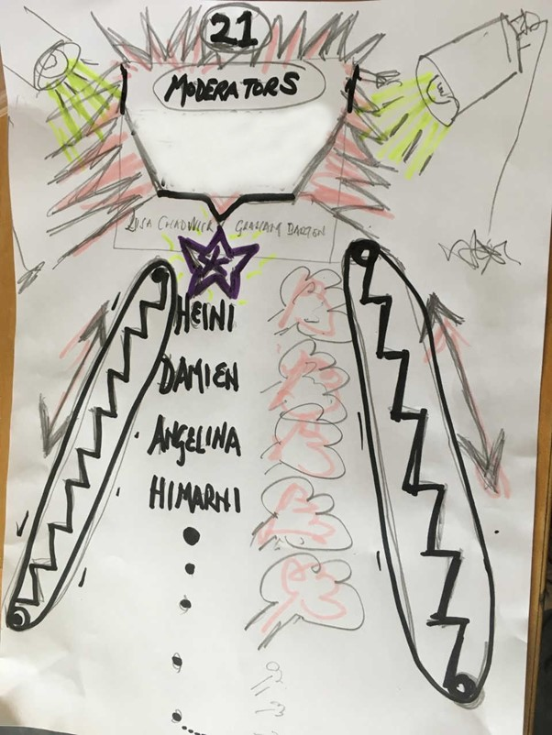
Figure 5
More disturbing in its expression of power-relationships is Figure 5.

We see an escalator, transporting participants up a steep slope to a platform or stage, from which contributions to the class or workshop are made. The escalator is depicted in a jagged style, suggestive of the teeth of a buzz-saw. The virtual environment is rendered in stark blacks and reds, with jagged edges and harsh spotlights trained on participants who have attained the privileged space at the summit of the escalator. The illustration captures the double anxiety of being ignored (never permitted to ride the escalator to the privileged space above) and the anxiety of participation (the spot-lit space above is harshly-lit, jagged, and stress-provoking in every way).

Discussion with the creator of Figure 5 confirmed that their image was not intended as specific representation of our workshop, but as a distillation of twelve months’ experience of online learning. The creator acknowledged that our own workshop was not overtly hierarchical, but emphasized the powerful residue of emotion that hierarchical experiences of online learning had left behind.

(6) Interpreting these experiences
A key topic that emerged in these workshops was the effect of isolation on a student’s sense of belonging, and thus their sense of empowerment and agency in class. As the creator of figure 5 expressed it:
When you are in a physical classroom, you can see to your left or right, and read other students’ body language, and gauge when is the moment to speak, to ask a question. In a virtual environment, there are none of those cues…

This statement echoes comments from teaching staff about the absence of body-language-based cues when speaking to an online student cohort. It also reminds us that even a traditional one-to-many lecture is a shared psychogeographic space, with non-verbal cues constantly passing between lecturer and audience. The online space nullifies this rich flow of information. This situation is further exacerbated when a student elects to turn their camera-off.

Workshop participants have a justifiable right to privacy, and camera use should be optional. Having a camera switched on can be seen as evidence of ableism. However, turning a camera off can be construed as a passive-aggressive behaviour. Anonymity is a key factor in determining how students interact in online learning. Even if anonymity is preserved, Chat or similar written messages remain permanently present and viewable. Although rightly heralded as improving accessibility for those challenged by speaking aloud, Chat functions can disadvantage students who need time to formulate and articulate ideas in writing, including international and neurodiverse learners. None of these factors work to facilitate a state of shared social presence.

Several of these illustrations highlight the illusory nature of the student cohort (or ‘body’) in an online environment. There is no physical student ‘body’ in such an environment – there is only a group of individuals and devices, connecting to the online event. Figures 1, 2, 3, and 5 all emphasize the isolation of the individual learner from the group.

Classrooms, workshops and studios that are regularly used by the same body of students for the same type of activity acquire over time the personality of those that occupy them. Posters and student work are attached to the walls. Objects made by students persist in the space, inflecting it with their energy. Chairs, tables, and other items of furniture move around, adopting familiar and recurring patterns. Yesterday’s dead coffee-cup is still visible on the windowsill, as today’s class commences.

Online learning and teaching spaces acquire none of this vernacular history. They are bare and neutral every time a class commences. Online ‘rooms’ lack the sophisticated spatial memory of a physical environment: the collective narrative linking events in a physical classroom to a time before and a time after. The dead coffee cup on the windowsill reminds everyone that yesterday the lecturer was thirsty or tired and drank a cup of coffee – and the evidence of that human event is still visible and present in our classroom.

Through the accumulation of such tactile memories, a classroom or a studio becomes a place, and can thus become a shared space. It is shared because its collective evolution is owned by all concerned. Such a classroom becomes a place in the sense that Marc Augé employs the term, in contra-distinction to the transient ‘non-places’ that he characterizes.
If a place can be defined as relational, historical and concerned with identity, then a space which cannot be defined as relational, or historical, or concerned with identity will be a non-place. [Augé, p.63]

Augé is speaking of physical non-places: airport lounges, railway coaches, motorway service stations. The history of the internet could be understood as a sustained effort to create places from non-places: to occupy and domesticate a frontier that possesses a superlative quality of otherness. It is, in reality, just a binary digital soup – as Anthony Vidler observes: ‘For what is spatial after all, about an endless string of 0’s and 1’s... displayed on a screen without depth’ (Vidler, 2000, p.231).

These student representations stress the absence of any personal investment in online learning spaces. Returned to over and again, they remain transactional spaces uninflected with individual or collective identities. As Augé writes: ‘What reigns there is actuality, the urgency of the present moment’ (p.83).

Hence the addiction to skeuomorphism, to domesticate online spaces with familiar symbolism: to (apparently!) transform spaces into places. But such skeuomorphism is deeply transactional. It exists primarily to enable users to navigate online spaces, and to acquire an online persona – a digital ‘twin’ as real as our body is real in the physical realm.

In such situations, we may experience a dissociative fugue, a mental state in which we lose our sense of identity. The psychiatric diagnostic manual DSM-5 defines the dissociative fugue as a state of ‘bewildered wandering’.

Figures 1 and 2 depict a physical space over which the student enjoys a high degree of agency: the desk at which they work and on which their computer rests. But this space is separate from the shared space depicted ‘behind’ the computer screen: a complex or contested space over which they have no direct control. This shared online space lacks the familiar classroom cues (‘in a physical classroom, you can… read other student’s body language…’). We may refer to spaces such as Blackboard Collaborate or Zoom as classrooms, but that does not make them resemble physical classrooms, where students’ repertoires of responses to familiar teaching situations are learned and iterated (see Seifert and Sutton, 2007; Horne-Martin, 2009; Pritchard, 2015).

In ‘What is Agency’, Mustafa Emirbeyer and Ann Mische characterize agency as emergent in specific contexts and situations. Social actors acquire agency by interaction with the totality of circumstances surrounding them. Social actors:
routinely construct simplifying models by means of which they characterize recurrent aspects of persons, relationships, contexts, or events. [Social actors recognize] the ‘sameness’, ‘likeness’, or ‘analogy’ of an emerging experience with those of the past…. (Emirbeyer and Mische, 1998, p.979)
This analysis fits well with Siefert and Sutton’s stress on the importance of recurrent and recognizable cues in teaching and learning situations:
Many class activities take on communication patterns that class members learn to expect without even being reminded… A lecture, for example, has a particular participation structure: students are responsible for listening, for raising a hand to speak…. (Siefert and Sutton, 2007, ch.12, p.1)
The classroom situation is a very powerful recurrent context: one we experience when we first go to school, which survives in recognizable forms through to postgraduate study. The classroom context can survive a wholesale and skeuomorphic translation into a completely different environment (‘the online classroom’). The apparent success of this translation (the power of the underlying model) generates a misleading sense of familiarity and therefore a confusing set of cues and expectations. Emirbeyer and Mische emphasize the complexity of relationships between past experience and access to agency in evolving situations:
Social actors not only identify similarities between past and present types of experiences; they also locate these typifications in relation to other persons, contexts, or events within matrices composed of socially recognized categories of identity and value … to locate correctly where given experiences fit within them and thus keep social relationships working along established lines. (Emirbeyer and Mische, p.980)

Thus, the ‘online classroom’ proposes – through its skeuomorphic imagery and nomenclature – a set of contexts and cues which appear to reproduce familiar experiences of education. But the behaviours that these cues and contexts demand are categorically different. For example, to raise a physical hand in a physical classroom is a communicative gesture loaded with nuances from preceding contexts. This simple action can be performed impulsively, decisively, languidly, eagerly, tentatively, nervously, ironically… and so on. In a physical classroom, a lecturer will recognize not just the fact that a student has raised their hand, but will also understand a whole set of signifiers by the manner in which the hand has been raised.

As Emirbeyer and Mische suggest: ‘emergent situations thus [call] for increasingly reflective and interpretive work on the part of social actors.’ (Emirbeyer and Mische, p.994). In the emergent non-place of an online classroom (at best, a non-place that is striving to become a place), the purpose of the non-place (learning) cannot be readily disentangled from the emergence of identity and agency within this new environment. As Augé observes:
…the word ‘non-place’ designates two complementary but distinct realities: spaces formed in relation to certain ends (transport, transit, commerce, leisure) and the relations that individuals have with these spaces. Although the two sets of relations overlap to a large extent, and in any case officially (individuals travel, make purchases, relax), they are still not confused with one another; for non-places mediate a whole mass of relations, with the self and with others, which are only indirectly connected with their purposes. (Augé, 1995, p.76)
Identity and agency must be mediated within new learning spaces before such spaces can be trusted to play their role in achieving students’ purposes. But the icons and signs that mediate these spaces into places have been constructed from the transactional non-places of internet commerce, intermingled with skeuomorphic cues from the physical classroom. Small wonder that confusion reigns.

Conclusion
As Etienne Wenger has remarked, ‘the negotiation of identity is the key issue in education today’ (Wenger, 2014). The negotiation of a student’s learning identity and (eventually) the achievement of agency in online learning spaces is a task for which both learners and teachers have been ill-prepared. During March and April of 2020, when universities across the UK were moving their teaching online, there was an understandable focus on the mechanics of the process: achieving technical competence on whatever platform was being used. At the pedagogic level, there was a general understanding that online learning should not mean replicating what would be attempted in a physical classroom. Nevertheless, the rapidity with which universities were obliged to move their learning online meant that there was little opportunity to reflect on the learning space itself, or explore its characteristic networks and relationships.

The computer screen is neither a picture nor a window, although we habitually treat it as either or both. In physical space, we control our own bodies. Our lack of agency over others is a part of what makes them ‘other’. In virtual space, we have no body. We are manipulators of a shared environment, as is manifest in collaborative online spaces and interactive tools such as Mural or Padlet. As Anthony Vidler observes, ‘Between contemporary virtual space and modernist space there lies an aporia formed by the autogenerative nature of the computer programme, and its real blindness to the viewer’s presence’ (Vidler, 2001, p.8). ‘Presence’ - in a shared social space such as Mural or Padlet – can be defined by the trace a participant has left behind.

When facilitating synchronous online learning, it is supremely tempting to envisage the computer as a large box which contains the class or classroom inside. But this is an illusion: there is no one, and no space, ‘inside’ the computer. Everyone is remotely present, and everyone is alone – as the drawings from our workshops testify. To quote a student participant, ‘We’re the centre of our own little worlds, but we’re connected within this wider environment.’

We need a new vocabulary, to enable us to move on from the skeuomorphic constructs that hamper our online interactions. The task of conceiving such spaces is beyond the scope of this article: we can only begin to speculate about them. Such spaces might not resemble physical classrooms or lecture theatres at all. They might more closely resemble the spaces that we currently think of as recreational – social media platforms. They could be composed of lines and points of intersection: paths, routes, crossroads and meeting points – Deleuze and Guattari’s multiply-interconnecting rhizomes. Meeting places and points of intersection are conspicuous by their absence in our participants’ drawings. Such spaces could facilitate new kinds of interaction, and not just mimic interactions from the physical world. They could become places, not spaces - and embody their own vernacular memories. They would acquire a past – and therefore, perhaps, a brighter future.

Error! Hyperlink reference not valid.

Error! Hyperlink reference not valid.

Error! Hyperlink reference not valid.

Error! Hyperlink reference not valid.
Error! Hyperlink reference not valid.

Error! Hyperlink reference not valid.

‘Skeuomporphic’: retaining ornamental cues and attributes that played a functional role in an earlier design

