Everything in 3D: Developing the Fashion Digital Studio
Philip DELAMOREª, David SWEENEYª
ªLondon College of Fashion,University of the Arts London, UK;

Abstract
Current thinking beyond the trends of mass-customisation and personalisation are towards more social, sensual and experiential notions of how Fashion is consumed and communicated. The notion of a commodity or product, and of mass appeal is fading in a multi-sensorial and always connected world, where personal identity is key.
The Fashion Digital Studio aims to address the notion and development of Fashion both as a product and as experience. The primary focus is on the translation of the real world fashion experience in its entirety into the world of digital, and managing the seamless interaction between the two. Computer vision, fast low-cost processing and high quality real-time visualisation of cloth is becoming possible and will drive the development of much higher levels of user experience and intervention in online retail, fashion media and publishing.
This paper will present the key outcomes of the development of 3D body scanning over the last 10 years. Highlighting the issues of adoption needed to successfully enable the mass-customisation model predicted by many, but which has yet to fulfill its potential. It describes new and emerging approaches in photogrammetry which may have significant impact over the next 10 years, enabled by low-cost accessible hardware and software, with the potential to democratise scanning for home and mobile internet shopping. Conclusions and recommendations will be made on how the future of inderdisciplinarity may drive innovation and skills in digital fashion.

Keywords: Keywords: Fashion Design, Bodyscanning, Photogrammetry, Mass Customisation

1. Introduction
The Fashion Digital Studio at the London College of Fashion has been established with the intention to bring together both the academic researchers and technical experts with the creative end users and consumers, designers and thinkers to challenge existing models of technology development. In this paper we aim to identify the key outcomes from the development of bodyscanning technology and its applications thus far, and to propose how these may be developed over the next 10 years in response to the challenges and opportunities presented.
2. Background
The existing methodology for the development of collecting human body sizing data using 3D whole body scanning technology has its origins in manual anthropometry techniques, with the key difference being that the 3D volume and shape of an individual could be accurately captured for the first time [1].
The development of this technology has required the collaboration of technical experts from different fields including computer science, anthropometry and garment technology. The bodyscanning systems employed are complex tools that require technical expertise, and are primarily used by trained operators. While they may be portable and suitable for use in retail environments, installation of such systems has remained largely within the laboratory and B2B sector, with a minority being employed in retail environments. For example, of the current 130 international installations by one technology supplier (TC2), 25 are in retail environments, while 105 in are within university, commercial, military or public sector research [2].

Creative users of these 3D scanning systems have approached them in a more playful and irreverent way. Fashion photographers such as Warren Du Preez and Nick Thornton Jones, Nick Knight, Solve Sundsbo and designers such as Boudicca and Hussein Chalayan have all experimented with using bodyscanning to create images, film and sculptural pieces which push the technology to its limits, i.e. to explore the aesthetic possibilities of representation of the human form and create innovative and challenging approaches to their medium.

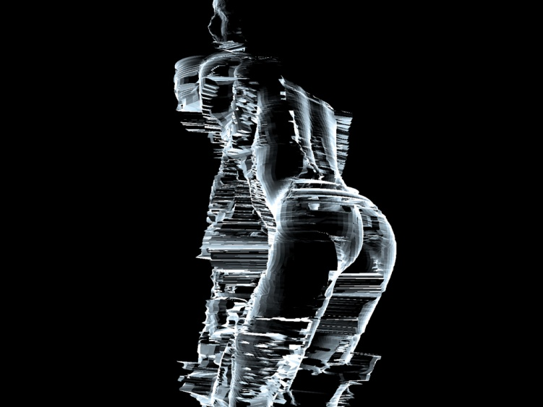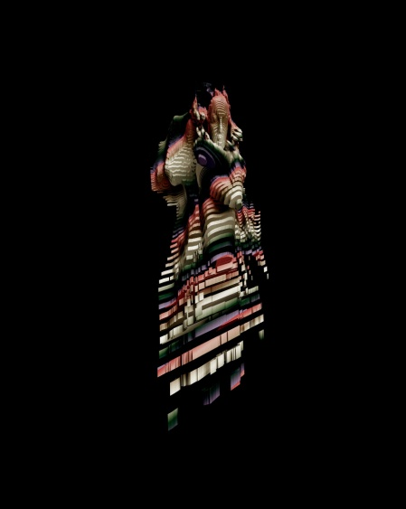
Fig. 1.Artworks using 3D scanning by Boudicca, Warren Du Preez & Nick Thornton Jones

The music video for Radiohead’s “House of Cards” which used real-time 3D point-cloud capture, and its subsequent media launch in collaboration with Google in 2008 may be responsible for disseminating this technology to a wider audience than would previously have been reached by any other means [3].

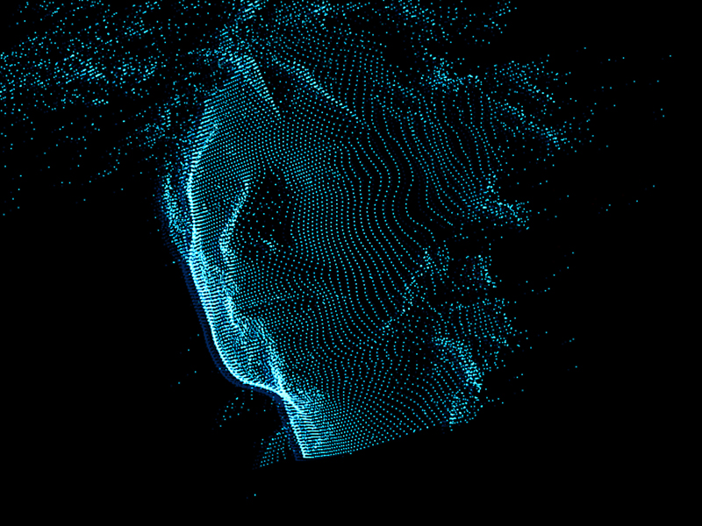
Fig. 2.Image from Radiohead “House of Cards” interactive music promo

To summarise, it can be both the creative users and the user-centered designers who are often the key to unlocking the potential of new technologies and making them more widely acceptable to the consumer. This can be seen in the development of multi-touch interfaces such as iPhone/iPad, and the rapid growth of content in the form of software applications (“apps”) enabled by allowing developers access to free or low-cost software developer kits. The increasing access to high performance, low cost computer hardware and software, and high-speed broadband Internet access has allowed a large enthusiast/amateur community to develop. They are able to compete with established large corporate developers and this has been instrumental to the development of a vibrant computer games and film post-production industry in London and the UK.

2.1 Key outcomes of 3D Bodyscanning for the Fashion Industries

The development and use of 3D body scanners for whole body capture and sizing surveys have given rise to a number of important advances in fashion product development, these include:

3D Shape - The improvement of commercial sizing and fit due to a better understanding of body shape in relation to size has been a key result of 3D body scanning surveys, and the development of tools to support product development including size charts which can be targeted at specific demographics, fit mannequins and pattern blocks can now be developed as part of a complete commercial integrated solution for product development (e.g. Sizemic, Alvanon). In addition an “evolutionary” approach to grading has emerged as the result of a better understanding of the distribution of weight over a range of sizes and ages, as opposed to traditional linear grading rules based on equally distributed incremental formulae [4]. As a result several studies have attempted to classify a range of body somatotypes, such as the FFIT (Female figure identification technique for apparel) as a graphical representation to assist consumers in identifying their personal body shape, in clothing labelling or online purchase [5].

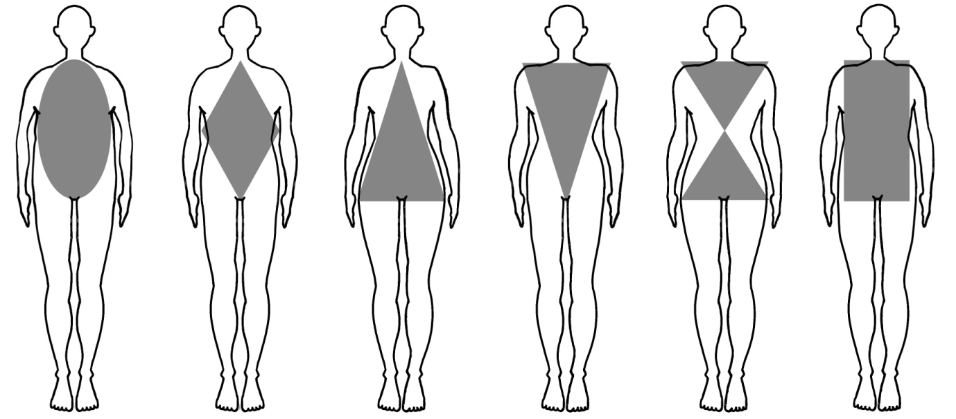
Fig. 3. Body morphotypes described as graphical shapes

3D Sizing Standards - A number of new standards have been developed to address protocols in diverse 3D scanning systems, including head, foot and handheld, where inconsistencies may arise from differing software and proprietary extraction algorithms [6]. The international standard ISO 20685 (2010, 3-D scanning methodologies for internationally compatible anthropometric databases) was developed to ensure comparability of body measurements from 3D body scanners currently specified by ISO 7250-1, 7250-2 (2008, basic human body measurements of technological design), and ISO 8559 (1989, garment construction and anthropometric surveys-body dimensions). It describes the protocol for reducing error in 3D scanning from three aspects, which are:

- Subject (anatomical landmarks, scanning garment, subject position)
- Hardware (resolution, hardware test and calibration, scanning volume, scanning duration)
- Software (human figure manipulation, landmark identification, segmentation, measurement extraction, data storage).

3D Fit – As well as scanning the body in order to understand shape and size, a number of comparative studies have used 3D surface scans of clothed figures to highlight problems of fit using qualitative assessment. This has been approached with two methods: one analysing body/clothing space using horizontal slicing of the figure, and the other using surfaced scans to highlight wrinkles or folds on the clothed figure [7,8].

3D clothing pattern design - New approaches have been developed in utilising the sizing data for automating individualised clothing pattern design. One is a 2D made-to-measure approach, using best fit and alteration, where the closest pattern from an existing database is selected from the measurements extracted, and then alterations are made to that pattern to tailor it to the individual. The other is a 3D bespoke approach where a parametric mannequin is developed from the individual bodyscan and patterns developed using tailoring formulae relating to the mannequin, or by drawing directly onto the surface to define style lines. The accuracy of these systems is dependant on the flattening algorithms used to unwrap the patterns from 3D-2D using darts as demonstrated by McCartney et al [9]. Physical mannequins may also be produced using this data to ensure physical prototyping and virtual prototyping are consistent.

3D Visualisation - Both approaches described above may then be visualised on a surfaced scan or virtual mannequin (avatar) as a virtual prototype for customer approval, alteration and design decisions can be decided before a physical prototype or final product is manufactured. These avatars are generated using animation techniques and are suitable for e-commerce applications. Often the avatars will be parametric, where the bodyscan is made symmetrical and surfaced, and these may be created from individual scans, or from an average of a population of scans for commercial sizing applications. 3D Visualisation systems (eg. Optitex, Browzwear) use a predefined avatar selected from a database, which may be adjustable to represent different body sizes and types, or are generated from an individual scan (TC2). The 2D patterns are then wrapped around the avatars using physics-based cloth modelling systems to visualize the drape of cloth. Much work has been done on developing accurate mathematical models from early work by Pierce in the 1930s to more recent developments by Kawabata, Provot, Thalmanns et al used for computer graphics application [10,11,12,13]. The recent development of hardware accelerated graphics processing means that the ability to model at yarn level, as demonstrated by Kaldor et al (see fig.4), will soon be available in real-time and this will mark a significant advance in the online experience of clothing [14]. Currently there is a trade-off between realism (accurate physical modeling) and believability (looking good) that divides the development of these systems for fashion and the film/games industries. The development of virtual prototyping has also been linked to design costing and electronic resource planning systems to enable designers to make efficiencies in the design phase of new product development, reduce waste and number of physical prototypes which must be made.

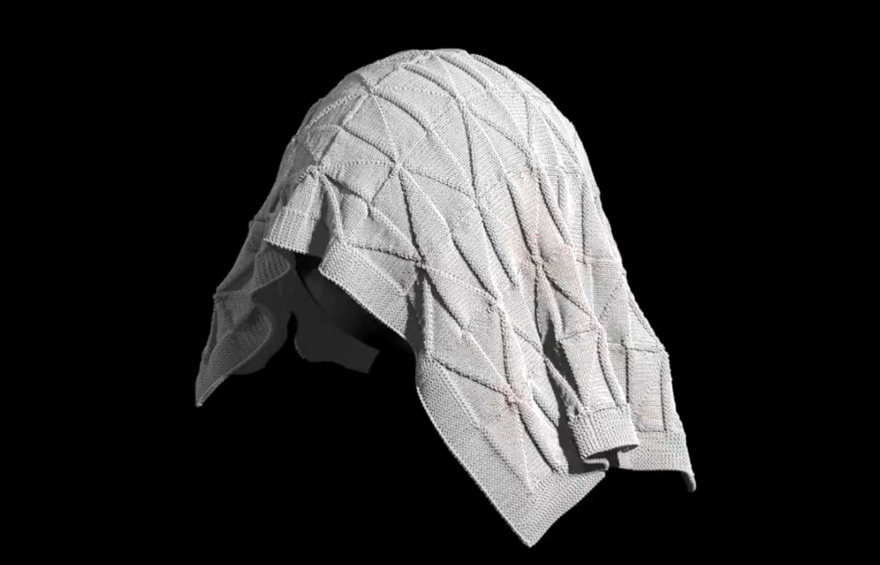
Fig. 4. CAD Simulation of Knitted Cloth [14]
2.2 Mass Customisation: integration issues
As described above, bodyscanning has had a significant impact on the development of digital tools for commercial clothing production, in relation to incrementally improved efficiencies in the product development process applied to current mass-manufacturing methods. The integration of the needs and desires of the individual consumer, as epitomised by the model of mass-customisation proposed by Pine and others as the next consumer revolution has so far failed to have the significant impact expected by many 10 years ago when the first 3D sizing surveys were undertaken [15,16]. This approach proposes that consumers become co-designers enabled by online platforms such as product configurators, to enable them to better specify products that are personalised to their own style and fit requirements prior to manufacture. For example Piller currently lists apparel in the top 3 of online configurator databases, with 176 apparel product configurators listed on this International Configurator Database, consisting of the following product types [17]:

- 105 T-Shirt/sweatshirt
- 42 Shirts
- 5 Jeans
- 5 Underwear
- 7 Sports clothing and accessories
- 12 Clothing including business suits, corporate wear, skirts and pullovers.

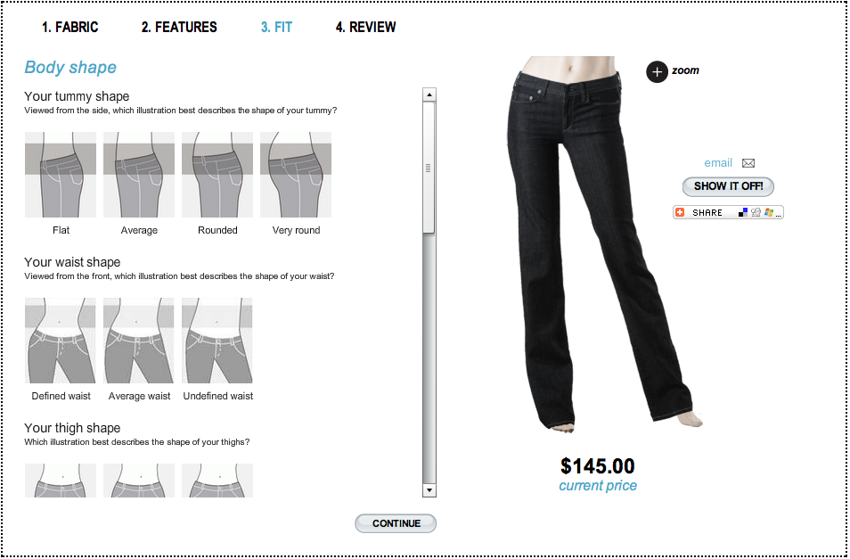
Fig. 5. Online Jeans Configurator

As we can see a minority of these are concerned with fit customisation, and these are reliant on customers to supply their own metrics or choose from predetermined morphotypes. The majority allow customers to simply choose colour or print options for mass-produced ready made garments such as T-Shirts.

Considering that US national statistics for e-commerce show apparel sales of $17bn for 2008, an 8.4% rise on the previous year, with 70% of all online sales being apparel [18]. This represents a huge marketplace that has not yet been given any significant offer in terms of online fit, style and product advice based on customer body shape. So how can the future of clothing retail be enabled by the technology developments which have happened in other fields, primarily in computer vision and user and experience design, and how can bodyscanning enabled size and fit information be delivered to such systems to enable consumers to find better fitting products?

2.3 Application of Computer Vision to bodyscanning
Most bodyscanning technologies are based upon specialised sensors and expensive rigs. The democratisation of 3D scanners for fashion will depend on the entry-level costs as well as their technical complexity being reduced. However there is one specialised sensor that has become ubiquitous in our lives: the digital camera. Most modern mobile phones contain at least one, and webcams have become standard peripheries on our computers and laptops [19]. They can produce images with 0.25-1 million (coloured) points, at rates around 30 frames a second. While these images are two dimensional, there are several software methods to calculate the relative 3D information that is contained within the 2D image, i.e. stereoscopy is widely used in reconstructing 3D scenes by using 2 cameras (this simulates how our eyes see the world) and is used in 3D television broadcasts.

Photogrammetry, where geometric properties are evaluated from photographic images, is a sub-ﬁeld of Computer Vision science (where computers are programmed to recognise objects and patterns algorithmically). Computer vision has begun to touch each of our lives, from face recognition on digital cameras, to Augmented Reality applications on mobile phones. Much of the development in computer vision is carried out by independent creative coders who are utilising open source tools such as OpenCV, a toolkit which offers the general public the ability to create their own computer vision applications [20]. The techniques aren’t new, but the ability of computers to process the images, and the quality of cameras that are used to capture these images have just only recently caught up to allow the systems to become useful to the general public. Computer vision will have a most profound impact on our lives in the near future, and is an example of true machine intelligence. In the future, we will learn to offload many of our daily tasks to machines which sense the world using computer vision techniques and we will become ever more comfortable with the numbers of cameras in our world and with how they interpret our environment for us. Recognition engines are constantly improving and the open source community is accelerating the development of this field by ensuring that the technology does not remain isolated within a silo of knowledge.
Computer vision-based scanners are particularly inviting because they only require a single piece of equipment with which we are all familiar - a digital camera. While a rig of cameras surrounding the subject to be scanned is preferable, there is potential for a single camera to capture sufficient information because computer vision techniques are much more dependent on the software and algorithm than they are on hardware.
The big challenges to overcome before suitable photogrammetry based scanners are available include: automatic segmentation of the subject from the background, automatic calibration of the scene and camera lens (focal length, lens distortion, etc.), and consistent tracking of features on the scan subject as the camera moves around (or as the subject rotates).

Time of Flight cameras, or “depth-cams” is also an extremely promising technology with regard to body scanning [21]. They work using a single lens and are made from very similar technology as a regular webcam: a CCD sensor [22]. They can capture the entire scene at once and can operate at up to 100 frames a second. By illuminating the scene with a modulating light of many MHz, these fast devices calculate a depth map by measuring the time for light to reflect off the subject and back into each pixel on the sensor. They are less susceptible to ambient illumination problems but reflective surfaces will still cause inaccurate readings. It is possible that they will eventually supersede regular cameras and will possibly provide depth information as standard. With these cameras, depth information doesn’t need to be calculated through photogrammetric means, as it is read directly from the camera feed.

2.4 User Experience Design
There is more to buying clothes than knowing what size you are, body scanners provide valuable sizing information that can be used to create highly accurate made-to-measure garments. Such accuracy is particularly desirable when producing functional apparel such as workwear, uniforms and sportswear, however in reality, achieving a perfect fit is only one of the forces that drive customers in retail situations [23,24]. To take full advantage of all that bodyscanning offers to the fashion and clothing industry, we need to appreciate that the experience of being scanned should resonate with how and why people consume fashion.
Recently, more emphasis has been put on creating retail environments that offer a complete experience, where customers are led on a curated journey from the moment that they enter the store until they leave. The architecture, store layout, music, imagery and even the smell of the environment are carefully chosen in order to create a narrative that strengthens both the brand and the take-home experience [25,26,27]. Associations are powerful influences on how we perceive these experiences and an ill-chosen stimulus can spoil the illusion and overall experience.

In essence, the fashion experience is more than just people clothing themselves. For many, it offers a means of self-expression and aspiration [28]. These are powerful human emotions and can entirely dictate how a product is perceived. As a result, the successful employment of body scanners within a fashion context should require a holistic appreciation of the entire experience, e.g. whether the technical nature of the device is in conflict with the rest of the experience, etc. [29] It is also important to explore the ‘personal service’ aspect of the tailoring / fitting experience, to see if it can be removed without compromising the customer’s expectations.

Augmented reality (AR) and virtual try-on can however be used to enrich the clothes shopping experience in a way that wouldn’t have been available before bodyscanning and computer vision systems. Augmented reality is a live view of a physical environment which is composited with computer generated graphics and text, etc. AR’s potential for use in fashion is well understood and may provide a platform for people to simulate garments or body modifications, and ultimately provide an arena where fashion is consumed.

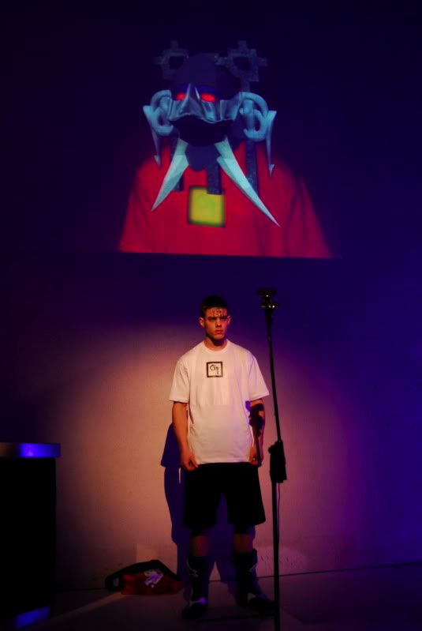
Fig. 6. Augmented Reality Fashion Show (CassettePlaya)

3. Methodology
Given the approaches described above, we can begin to consider what the drivers and metrics for new approaches to body scanning might be. In the next section we propose how systems for retail and home body data acquisition could be developed to better enable mass-customisation processes, and survey the metrics required for the comparison of systems suited to laboratory, retail and home use.

3.1. Quantiﬁable metrics for evaluating scan technologies.

Accuracy - how dense is the resulting point cloud, and more important, how representative is it of the subject being scanned?
Capture speed - how long does it take to complete a scan? Long scans require the subject to remain still for longer, increasing the chance that the scan will be incorrect due to the inevitable movement.
Processing time - how long does it take for the software to process the sensed data and convert it into a usable point cloud or meshed model? Generally more desirable to have a shorter capture time and trade it for a longer processing time if scanning objects that are susceptible to motion (such as people).
Surface invariance - does this scanning technology scan equally well regardless of the surfaces being scanned? How does it handle hair, reﬂective and smooth, homogeneous surfaces?
Field of view - what are the dimensions of the scanning volume? Can a single scan capture the entire subject or does the model need to be stitched together from many scans? Can a scan be completed regardless of the distance between the sensor and the subject?
Movement - does this scanning technology allow the possibility of capturing in 4D? (motion capture and surface scanning simultaneously). How many times a second can this technology capture a scan? Can the entire processing be done within this frame interval, allowing this scan technology to operate in real-time? What resolution (point density) can be achieved if capturing > 25 frames per second?
Ambient conditions - what are the environmental dependencies that this scanning technology is subject to? Can it intelligently distinguish the subject’s boundary from objects that are not of interest? Can the model be easily segmented out from all background noise? How sensitive are the results to the ambient lighting conditions?
Space - how much ﬂoor space does this scan technology require, including the scan stage, the scan sensors and any periphery processing units that maybe required? Can the scanner exist within an arbitrary environment or must it be positioned in a particular fashion within a controlled environment?
Ofﬂine operation - can a scan be carried out upon prerecorded data or does the subject have to be in the same location as the scanner itself? Can the scan data be processed upon a remote server?
Calibration - how difficult and time consuming is the calibration procedure? How sensitive are the ultimate results to the accuracy of the calibration? What are the variables in the hardware, environment, etc which may require pre-calibration? (Lens distortion, white balance, exposure settings, etc)
Hardware costs - how much does the scanner cost to produce? How much do the supporting technologies cost to license? Is there a possibility that wider adoption could decrease costs? Do the costs limit this technology for sole use within a high-end store or research lab, or could it be cheap enough for use within the home?

3.2. Identifying different scanning requirements
We need to distinguish between the two separate varieties of scanning technologies: highly accurate surface scans that are tuned for use within controlled environments, and lower-ﬁdelity, real-time scanners for use in more social, entertainment and immersive activities. Exposing users to controlled environments and technical machines may create certain psychological responses, some of which may be incompatible with the fashion experience. With some scanning systems, it would be near impossible to isolate the experience of being scanned from the sense of being immersed within technology. This could potentially destroy the experience that a fashion designer or retailer wishes to expose the user to.
To help categorise each scan technology for its suitability to operate within either a controlled or within a generic environment, we attempt to answer each of the questions contained in the quantiﬁable metrics section above. This will help us identify which details are key components for each scanning mode.
It can be seen below that the home scanner is subject to a tighter speciﬁcation; this would suggest that fewer technologies would be ultimately suitable for use at home. (Home scanning refers to non-specialist scanning or sizing, which could also include mobile phone based scanning, etc.)

Table 1. Comparison of scanner suitability for different environments

 | Laboratory | Retail | Home
Accuracy | High accuracy and dense point-clouds are essential | Measurement accuracy expected by customers | Possibly could trade high accuracy for shape sensitivity
Capture Speed | Capture speed not critical in controlled environments - can rescan in case of error | Must scan quickly to ensure that inexperienced users produce steady scans | Wide adoption relies upon good usability, therefore fast capture important
Processing Speed | Processing speed not critical - usually powerful computers are available | Highly distracting environments - need to feedback results quickly to customer | Processing speed may be an issue on standard PCs - server based processing possible
Surface Invariance | Not critical - surface can be treated or reconditioned to be captured easier (white powder, etc) | Application of materials to improve capturing impossible (white powder, etc.) | Needs to be fairly insensitive to surface variations - intelligent algorithm could fill the blanks
Field of View | Stitching multiple scans is possible - human intervention can be utilised | Ideally scan is completed in a single pass - mirrors could be used to increase field of view | A single scan, or a single interaction is preferable - needs to view the entire subject at once
Movement | Additional expensive hardware can be used to capture both the model and motion | Virtual try-on ‘mirrors’ would need multiple scan frames (10+) per second | The same technology would need to capture both the model and the motion
Ambient Conditions | Conditions can be adjusted to best suit the scan technology | Retail environments can be very brightly lit, should be capable of working in a variety of conditions | Must operate in most environments regardless of conditions
Space | Generally no pressure on footprint size | Retail floor space is expensive, instead of dedicating space solely for scan use, changing rooms could be used to house scanners | Must work within arbitrary sized spaces
Remote server processing | Good local processing resources are generally available | Would be useful - keep local hardware requirements low | May need this option as most home PCs are not specialist machines
Calibration | Can be taken offline to be calibrated on demand | To avoid specialist operators, self-calibration preferred | Ideally, infers calibration information automatically from the available scene
Hardware Costs | Dedicated labs or stores can absorb the costs | In-store use will be justified by market forces | Has to be cheap - ideally with no extra cost to the end user

Table 1: indentifying necessary requirements for scanners
in different types of environment

3.3. Analysis of home scanning requirements
From the comparison above we can make the following recommendations for the development of a home scanning system:

- It needs to be hardware-efficient, using nothing specialist or expensive, and ideally using hardware already available in the home. It needs to be environment independent - there will be no control over the setting
- It needs to work over a range of ambient illuminations - there will be no control over how the scene is lit, only recommendations can be given.
- It needs to operate on a simple PC, phone or other digital device - this would limit the processing the scanning software could carry out, however if it is connected to the internet, then the processing could be done on a remote server and the 3D model could be passed back to the computer for viewing, etc.
- A home scanner will probably need to infer it’s own calibration data, as a regular calibration routine may be beyond the patience of the general online shopper.
- Provision should be built-in to allow a wide variety of hardware to be used. A speciﬁc hardware solution should be seen as a replaceable technology, one that can integrate into a wider system of home scanning - this includes semantic style-based knowledge, databasing, stock management, visualisation and intelligent measurement extraction, etc.
- It should offer the customer tangible beneﬁts: it should be fun to use, easy to understand and to operate, and provide fulﬁllment by offering previously unknown insights into personal ﬁt, shape, style, etc.
- A home scan will likely have a lower level of detail than one done at a professional facility. In order to ensure that this is still useful, it is important to compliment this data with other known information, such as previous scans, cultural distributions, and fashion and body-shape trends.

The hardware requirement is the issue that most limits the choice of technology. Laser scanners can be made reasonably cheaply, but they require complex supporting hardware, sensitive cameras and rigs, which are both bulky and necessarily complex, enough to take them out of the reach of the entire general public. They also demand a level of environmental control and stillness from the subject, which will be considered inconvenient for use at home.
By applying the same analysis to the other major scanning technologies as they exist currently, such as white light scanning, radar, microwave and CAT scanning, etc, we see that they each have little potential for wide adoption, due to their dependence on specialist emitters and sensors.

4. Conclusions
We have described the development and application of 3D bodyscanning technologies in the fashion industries, and identified the key positive developments in 3D design, shape, and visualisation as well as the barriers to its widespread adoption in retail, as had been predicted. The next generation of 3D scanning tools will be much more flexible, user oriented and non-technical. In the case of fit and sizing tools then they will need to take account of technological developments in other industries, along with improved understanding of the user experience, and be more engaging, consumer driven products. To initiate the diffusion of 3D scanner technology out from the laboratory and into the home or retail setting, the dependency upon hardware must be replaced with a software driven model. In order to do this we need to draw on expertise from creative, as well as technological experts, and to develop new interdisciplinary approaches to research and development in digital fashion.

References
- Bougourd, J., Dekker, L., Grant-Ross, P. and Ward, J.P., “A Comparison of Women’s Sizing by 3D Electronic Scanning and Traditional Anthropometry”, The Journal of The Textile Institute, 91(2), part 2, pp 163-173, 2000.
- Bruner, D., (2010) in personal correspondence
- Radiohead “House of cards” accessed (2010)
http://code.google.com/creative/radiohead/
- Kung, A., “Parametric Pattern generator: The Applied Science To Give Critical
Advantages”, IMB Forum Congress, Cologne, Germany, October 2004.
- Istook, C.L., Simmons, K.P., Devarajan, P. Female Figure Identification Technique
(FFIT) for apparel. Proceedings of the IFFTI International Conference, Hong Kong,
Nov 2002
- ISO Standards accessed (2010)
http://www.iso.org/iso/catalogue_detail.htm?csnumber=35514
- Ashdown, S.,Mete, F. “Development of Visual Fit Assessment Tool for Apparel
Firms”, NTC Project S08-CR03, accessed (2010)
http://www.ntcresearch.org/projectapp/?project=S08-CR03
- Ashdown, S., Loker, S., Rucker, M. “Improved Apparel Sizing: Fit & Anthropometric
3D Scan Data”, NTC Project S04-CR01, accessed (2010)
http://www.ntcresearch.org/projectapp/?project=S04-CR01
- McCartney, J., B.K. Hinds, B.L. Seow “The Flattening of Triangulated Surfaces
Incorporating Darts and Gussets”, Computer-Aided Design, Elsevier Science,
Num 31, pp.249-260, 1999
- Peirce, F.T, “The Handle of Cloth as a Measurable Quantity”, Journal of The Textile
Institute, Vol(21) pp377-416,1930.
- Kawabata , S., Niwa, M.,, Kwai, H., “The finite deformation theory of plain weave
part I to III” Journal of the Textile Institute pp 21–85, 1973
- X. Provot. “Deformation constraints in a mass-spring model to describe rigid cloth
behavior”, Graphics Interface, pp 147-155, 1995
- Thalmann, N., Thalman, Yang, Y., D.,Carignan, M.“Dressing animated synthetic actors with complex deformable clothes” In proceedings of the 19th annual conference on Computer graphics and interactive techniques, pp 99 – 104, 1992
- Kaldor, J., James, D.L., Marschner, S. “Simulating Knitted Cloth at the Yarn Level”, In Proceedings of SIGGRAPH 2008, Los Angeles California, 2008
- Pine, J.B., “Mass Customization: The New Frontier in Business Management”,
Harvard Business Press, 1993
- Tait, N. “3D Body Scanning - A fitting service”, in Company Clothing Feb 2000,
accessed (2010)
http://www.just-style.com/analysis/3d-body-scanning-a-fitting-service_id92876.aspx
- Internet Configurator database accessed (2010) http://www.configurator-database.com/services/configurator-database
- U.S. Census Bureau, 2008 Annual Retail Trade Survey accessed (2010) http://www.census.gov/retail/index.html
- Kindberg ,T., Spasojevic, M., Fleck, R., Sellen, A. “The Ubiquitous Camera: An In-Depth Study of Camera Phone Use”, IEEE Pervasive Computing, v.4 n.2, p.42-50, April 2005
- Noble, J. "Programming Interactivity: A Designer's Guide to Processing, Arduino, and open Frameworks", O'Reilly, 2009.
- D’apuzzo, N., “Recent advances in 3D full body scanning with applications to fashion and apparel” In: A. Gruen & H. Kahmen (Eds.), Optical 3-D Measurement Techniques IX, Vienna, Austria, 2009.
- Oggier,T., Lehmann, M., Kaufmannn, R., Schweizer, M., Richter, M., Metzler, P., Lang,G., Lustenberger, F., Blanc,N., “An all-solid-state optical range camera for 3D-real-time imaging with sub-centimeter depth-resolution” (SwissRanger), Proc. SPIE Vol. 5249, pp. 634-545, 2003.
- Paquette, S. “3D scanning in apparel design and human engineering”, IEEE Computer Graphics and Applications, 16(9):11—15, 1996.
- Reynolds, K.E., Beatty, S.E. "Customer benefits and company consequences of customer-salesperson relationships in retailing", Journal of Retailing, Vol. 75 No.1, pp.11-32, 1999.
- North, A.C., Hargreaves, D.J. and McKendrick, J. “In-store music affects product choice”, Nature, Vol. 390, p. 132, 1997.
- Knasko, S. “Ambient odor and shopping behavior”, Chemical Senses, Vol. 14 No. 5, p. 719,1989.
- A Taylor, R Varley, “Embodiment in 3D virtual retail environments: exploring perceptions of the virtual shopping experience”, eprints.hud.ac.uk, 2008
- M Barnard, “Fashion as Communication”, Contemporary Sociology, 998, VOL 27; NUMBER 1, p. 76
- Loker, S., Cowie, L., Ashdown, S., Lewis, V.D., "Female consumers' reactions to body scanning", Clothing and Textiles Research Journal, Vol. 22 No.4, pp.151-60, 2004

Image credits
- L to R: © Boudicca, © Warren Du Preez & Nick Thornton Jones
- Radiohead viewer (downloaded 2010): http://code.google.com/creative/radiohead/viewer.html
- © Johnathan Kaldor
5. © www.indidenim.com
6. © Cassette Playa

p.delamore@fashion.arts.ac.uk; +44 207-514 2294; www.fashion.arts.ac.uk

