The future of TEXTILES sourcing: EXPLORING the potential for DIGITAL tools
Bruna Petreca¹
Douglas Atkinson²
Dr Nadia Bianchi-Berthouze³
Dr Dominic Furniss³
Dr Sharon Baurley¹
¹Royal College of Art, School of Design - Design Products
²London College of Fashion, DISC (The Designer Manufacturer Innovation Support Centre)
³University College London, UCL Interaction Centre (UCLIC)
bruna.petreca@network.rca.ac.uk
d.atkinson@fashion.arts.ac.uk
n.berthouze@ucl.ac.uk
d.furniss@ucl.ac.uk
sharon.baurley@rca.ac.uk

Abstract
Textile selection involves aspects of objective function and subjective experience. While technical assessments of textiles are extensively supported by standards and machinery that provide the industry with rigorous specifications, the more subjective characteristics remain heavily reliant on designers’ tacit knowledge, experience and intuition. In this paper we present a study that investigated designers’ textile sourcing activities and if and how digital tools could provide support. The study was conducted in a textile fair with an expert audience in the mind-set of sourcing. An existing digital tool that allows textiles manipulation was introduced to familiarise participants with the digital context and enable conversations on the future of textiles sourcing. We also look at the implications of adopting digital tools for their activities including a transition to more sustainable practices. The results raise awareness of designers use experiential information to support textiles sourcing, besides highlighting requirements for designing future digital tools.
Keywords: design research, design tools, textiles selection, tactile interactions, user experience.
Introduction
Fashion has significant economic weight as an industry and textile selection is crucial for its success. Textile selection involves aspects of function and subjective experience. Technical assessments for characterisation and performance are extensively supported by standards and machinery (Behery, 2005), providing the industry with rigorous specifications (Bang, 2009), whereas more subjective characteristics are heavily reliant on designers’ tacit knowledge, experience and intuition. This highlights a need to support the balance between technical and experiential information as noted in materials and design research (Ashby and Johnson, 2003; Miodownik, 2007; Karana et al., 2008, 2009; Van Kesteren, 2010; Rognoli, 2010; Karana et al., 2013). Further investigations are needed to expand the development of tools for textile sourcing to support designers’ use of experiential information.
Previous research presented methods for objectively and subjectively assessing haptic properties of fabrics for quality assurance and predicting performance for engineering purposes (Behery, 2005). However, engineering-based research requires specialist knowledge for its use and interpretation, and the relation to intangible characteristics is not straightforward. Therefore, it has been of little or no use for designers wishing to communicate formal and expressive features in a meaningful manner to stakeholders (Pedgley, 2009). More recently triads and design games to facilitate articulation of emotional values were proposed (Bang, 2011), but are still not widespread in industry.
Interactive technology developments to support design activities were noticed (e.g. Dillon et al., 2000; Magnenat-Thalmann and Bonanni, 2008; Philpott and Summers, 2012), but little research was conducted specifically to support textile sourcing. Here we present a study conducted at a textile trade fair to explore (1) how designers source textiles and engage with them during this process; and (2) if and how digital tools could support designers in this activity. We report the results and its implications on the design of tools to support textile sourcing. Before presenting our study we review the related literature.
It is common practice in the fashion and textiles field to travel abroad visiting fairs where companies showcase the latest innovations. We chose this context for the investigation as it also offered an ecological approach as we could observe and question experts while they were performing the sourcing activity. As interactive digital tools for handling fabrics are at an embryonic stage and most textile experts may lack experience of using them, an App called iShoogle (Orzechowski, 2010) was presented as research tool; its use aimed to cue textile experts to discuss how such tools should be designed for use in sourcing activities, as well as to identify in which stage(s) of the design process they would be desirable.
The fair we attended focuses on fabrics with reduced environmental impact. As such we considered that the visiting experts would be open to the idea of digital tools that could offer new more sustainable alternatives to the current market models for sourcing textiles. We wanted to understand experts’ perceptions of their current practice and how open they are to change to more sustainable conduct, provided that technology offers alternatives to gather the information they need about materials.
Background and related work
In this section a literature review is presented following our research questions. The first section comprises what is known about designer’s sourcing of textiles, including research into the design process (focusing on useful information for materials selection) and textile-engineering research (highlighting the focus given to perceptions of textiles elicited through the sense of touch). The second section comprises analogue and digital tools to support designers when sourcing, with applications in research, industry and retail.
What is known about designers’ sourcing of textiles?
Designers’ knowledge
Fashion and textile designers are familiar with the physical characteristics and aesthetics of textiles, besides its suitable applications and contexts of use. They rely on multiple resources for inspiration and research – personal, cultural, market and trend related (Bang, 2009), which they must skilfully articulate in design proposals and communicate to design teams and stakeholders, to guarantee their concepts are translated through manufacture and use. Such knowledge is innate (reliant on designers’ sensibility and intuition) and tacit (acquired through training and experience) (Dormer, 1997).
Fashion and textile designers share similar design process patterns that usually move iteratively from a problem, question or need towards a solution (Design Council UK, 2005; Newman, 2011). Communication in this process is usually verbal, visual or through samples, and frequently is multimodal. This recalls Dormer’s (1997) definition of distributed knowledge that designers rely on the environment they work within – the social, organisation and the physical environment – to form their knowledge basis, test concepts and support decision-making processes. Fashion and textile designers use, for example, mood boards, samples and toiles as “things to think with” (Kirsh, 2013) and communicate or explicit their thoughts through. Kirsh (2013) suggests sensory experience and interaction with things as crucial for our understanding; which is also why prototypes facilitate reasoning, simulation and focusing by allowing people to project their ideas, creating “cognitive support”. This is aligned to the embodied cognition perspective, which proposes that we perceive the world with connected body and mind (Merleau-Ponty, 2002).
Touch for fabric sourcing
Studies show that clothing texture is a pervasive element to human perception (Laughlin, 1991), that tactile interaction is crucial for consumers primary judgments of product quality (Jordan, 2008) and that marketing communications incorporating tactile elements lead to increased emotional response in consumers that may influence decision-making processes (Peck and Wiggins, 2006). So far textiles-related research mainly focused on verifying the effect of physical characteristics and performance of textiles, to support the description of attributes perceived through touch, and for predicting textiles’ characteristics in manufacturing and quality control. Studies mostly covered themes of ‘fabric hand’, comfort to wear and aesthetic responses (Brandt et al., 1998). ‘Fabric hand’ is a disseminated concept in the textile industry. The definition we adopt (Atkinson et al., 2013) was proposed by Philippe et al. (2003) as “... the reaction of the sense of touch, when fabrics are held in the hand. (...) ‘hand’ can be considered as a meta-concept that takes into account not only the sensory aspect but also aspects such as formability, aesthetics, drapability and tailorability”. Most available definitions are included in a recent review on the hand of textiles (Ciesielska-Wróbel and Van Langenhove, 2012), which the authors combined to devise their own definition of the subjective hand of textiles.
Subjective analysis has been employed for characterisation of the tactile properties of textiles (Bensaid et al., 2006), to assess consumer preferences (Philippe et al., 2003), to verify quality and suitability of new fibres, material structures and finishing, and for fibre blend characteristics of handle analysis (Howorth and Oliver, 1958). Diverse methods have been applied in subjectively assessing fabrics considering the many variables involved (Laughlin, 1991, Guest and Spence, 2003, Philippe et al., 2003, Behery, 2005). In pursuit of more tangible information, objective measurements serve to complement subjective analysis (Howorth and Oliver, 1958, Cho et al., 2002). In objective evaluation (Behery, 2005; Kawabata, 1982) defined properties of a textile are assigned numerical values, which can then be interpreted to indicate how it is expected to feel (e.g. a fabric with a high bending rigidity measurement is expected to feel stiff). Objective systems require specialist technical knowledge to interpret results and this approach overlooks the semantics related or intangible information. Therefore, it has limited use for designers, whose selections are based on their sensibilities and experience acquired through training and practice (Bang, 2007).
Tools to support designers
Resources for sourcing
Physical materials libraries and trade fairs offer a wide range of materials and are curated to showcase the most innovative, allowing designers and product developers to be updated in terms of future trends (Mani et al., 2013). Besides the objective information related to characteristics and performance of materials, many factors must be considered for supporting the subjective experience, e.g. mode of display, environmental conditions, accessibility (Amaral et al., 2012). Digital databases offer predominantly technical information on a wide range of materials that can be retrieved, compared and connected to suppliers. Product engineers and material scientists are their main users to whom performance rather than aesthetic needs are paramount (Mani et al., 2013). Here the cognitive ergonomics is crucial to navigate the information system (textual and visual content), for the understanding and comparison of samples (Amaral et al., 2012).
More recently initiatives were noticed such as the Making app, a tool for comparing materials based on Nike’s Materials Sustainability Index (MSI), which specifically provide designers with sustainability-related information.
Sensory and aesthetic approaches for selecting materials
Research into general materials selection explored subjective aspects to support designers beyond technical specifications requirements. These approaches are more experience-related and often subject to culture, market, time, place and context diversity. Such initiatives are user-centred and reveal novel approaches to include stakeholders in the design process, i.e. material selection. Some included the development of tools, such as the Meanings of Materials tool (Karana, 2009) – which guides participants on the investigation of sensory aspects of materials that they relate to a predefined design intention, the Expressive-Sensorial Atlas of materials (Rognoli, 2010) – which links objective properties to subjective qualities through the use of illustrative charts, and the Stakeholder Game (Bang, 2011) – which engage stakeholders in a game to develop emotional concepts for future design based on personal experience. There is also an automotive industry tool created by Renault, the Sensotact®, a reference instrument for the tactile characterisation of materials (Allione et al., 2012).
Interactive tools supporting design
Besides research-oriented or materials selection tools, the industry provides practical tools, which support designers’ activities and are accessible even to non-experts. These tools mediate designers’ interactions with materials (organising and/or augmenting their sensory perception or providing ‘invisible’ technical information) and support the design process at different stages.
Some examples are the Pantone paper tools and Capsure – which facilitate communication by providing a common language to guarantee colour definition and reproduction; and Adobe Kuler – a synthesis of colour research into a tool for both experts and non-experts. This could be extended to interact with other senses as in the Ophone, a sensory communication tool that allows sending olfactory messages instantly over long distances, or through haptic feedback as presented in the Poke project (Park et al., 2013).
Interactive technologies for e-retail, or fashion and textiles co-design are emerging to support designers’ activities. Whilst interesting progress is being made in overcoming technological limitations, these show and adopt a narrow understanding of experiencing fabrics, as they do not support natural engagement of the senses (e.g. touch, sound). Developments initially focused on visual and verbal channels, and only recently studies are addressing tactile aspects (Dillon et al., 2000; Magnenat-Thalmann and Bonanni, 2008; Wu et al., 2011; Philpott and Summers, 2012), mostly through tactile feedback. Still, current interactive media presentations of textiles poorly communicate their ‘hand’ and less attention was given to gestures for handling textiles, or other properties (e.g. sound) and therefore to the type of technology needed to support such experiences.
Atkinson et al. (2013) addressed the latter question, showing that textiles are animated differently in response to being handled with different gestures. Gestures used by non-experts to assess textiles through hand tactile interaction were explored, and from these observations techniques were devised to create interactive simulations of digital textile handling for touch-based display (Atkinson et al., 2013). The experiments highlighted that the use of gesture influences the level of user engagement, possibly due to visual and proprioceptive feedback (Bianchi-Berthouze, 2013; Wu et al., 2011), and emphasised restrictions presented by the flat, rigid displays to the users’ experience as they limit and alter the types of gestures that can be used to handle textiles. Building on this knowledge we took an embodiment perspective of affective touch behaviour in experiencing textiles (Petreca et al., 2013), to discuss how an experiential perspective may be more aligned with designers’ activities.
Future Fabrics Expo (FFE) study
We proposed a qualitative explorative study with specialists in the fashion and textiles field to investigate their sourcing activities. We used an existing interactive tool – iShoogle (Orzechowski, 2010), to familiarise participants with the digital context and enable the investigation of their behaviour and to verify opportunities for developing digital tools to support textiles sourcing.
Method
Context of study
The study was conducted in-situ during the third FFE (organised by the Sustainable Angle) held at Fashion SVP in London on 22-24 September 2013. This fair exhibit hundreds of textiles from more than 50 international companies committed to reducing environmental impact throughout the supply chain. In this fair, as in many others, visitors are not allowed to collect samples immediately; they must request samples from exhibitors.
Design of the study
The study explored fashion designers’ behaviour and needs when selecting textiles, around the questions: How designers source textiles? and How digital tools could support designers in this activity? These were addressed through the following activities:
- Investigating designers’ needs: Participants responded to an introductory questionnaire providing information related to their field of expertise and textile sourcing activities, concerning criteria for selecting and knowledge base. Considering time constraints inherent in the fair, questions were simplified in a manner that would still provide necessary insight into their information needs.
- Investigating designers’ reactions to a digital tool: Participants interacted with digital samples to express their impressions of them and discuss opportunities for digital tools, prompted by open-ended questions displayed on a board to which their answers were attached using sticky notes (Figure 1). The questions were related, but not limited to the tool being demonstrated.
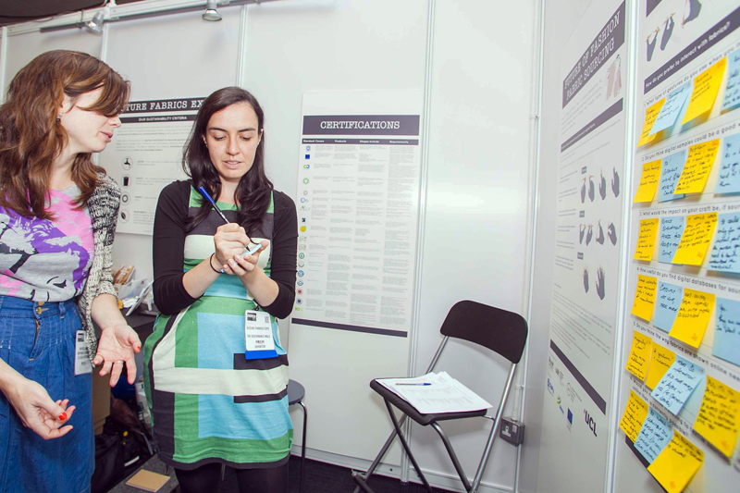
Figure 1. Picture from the study setup. © The Sustainable Angle Photography Green Lens Studios 2013. Source: http://www.thesustainableangle.org/futurefabricsexpo/Photos/FutureFabricsExpo2013.aspx
Participants
The study was approved by Local Ethics Committee and participants provided written consent. Participants were recruited at the fair and had been identified beforehand as a specialist audience. In total 24 visitors participated in the study, from which half had more then three years of professional experience, and the other half had up to three years of experience or were still completing undergraduate courses. Their specialty was distributed between apparel industry (12 participants), education (4 participants) and others (8 participants).
Apparatus
The main apparatus were an introductory questionnaire for activity one and the iShoogle tool and board with questions for activity two.
1. Introductory questionnaire
The questionnaire had four questions: two concerning designers’ area of specialty to certify they were specialists in the field; the third question involved criteria for selecting fabrics and the fourth included sources of information designers’ use when selecting textiles. Multiple-choice options were developed for questions 3 and 4 with reference to the literature, in Tables 1 and 2, where only the first column was presented in the questionnaire. Answers were chosen from a provided answer sheet.

2. Using ‘iShoogle’ to explore the scope for digital tools to support designers when sourcing fabrics
Table 2. Questionnaire options for information sources (Question 4)
Option | Definition | Term mentioned by
Exhibitions | Art and design related exhibitions. Form part of designers’ experience | Van Kersteren, 2008
Personal experience | Knowledge from education and previous projects | Van Kersteren, 2008
Supplier or manufacturer | Provide information through direct consultation | Van Kersteren, 2008; Karana et al, 2008
Sample collections | From previous projects or commercial collections | Van Kersteren, 2008
Internet | Use of the internet to search for materials and suppliers | Van Kersteren, 2008; Karana et al, 2008
Tradeshows | Information about latest materials and solutions | Van Kersteren, 2008
Books | Used as source of general information about materials | Van Kersteren, 2008; Karana et al, 2008
Tests and experiments | Experimenting with materials or tested by specialised third parties | Van Kersteren, 2008
Example products | Previously bought or seen in advertisement; from competitors | Van Kersteren, 2008
Magazines | Trend or suppliers information | Van Kersteren, 2008; Karana et al, 2008
Brochures | Brochures are sent from materials suppliers | Van Kersteren, 2008; Karana et al, 2008
Personal collection | Samples stored from previous projects, findings from shops or trips. | Van Kersteren, 2008
Databases | Software tools that support general selection | Van Kersteren, 2008
Films | Form part of designers experience and repertoire | *
Vintage shops; Museums | Considering fashion cyclic trends, museums and vintage shops can serve as research for identifying materials of interest. They also form designers’ experience. | *
Apps | Provide designers with information about materials (e.g. Materials Council and Making app) | *
* Items added considering current industry developments and practices specific to fashion designers, which were not included in other literature.
Table 1. Questionnaire options for criteria for selecting fabrics (Question 3) further categorised into objective and subjective
Option | Definition | Term mentioned by | Category
Application | Aspects related to the context of use | Jenkins and Lamb, 1987 | Objective
Composition | Quantified fibre type | Jenkins and Lamb, 1987
Fibre characteristics | The physical properties that differentiate fibres. Fibres can be natural (vegetable or animal) or man-made (synthetic and artificial). They differ in terms of performance, comfort, durability, care and price, amongst other specific qualities | Jenkins and Lamb, 1987
Performance | Related to the material behaviour under specific conditions and in use | Van Kersteren, 2008
Thermal properties | Physical properties related to touch perception: thermal capacity and thermal conductivity | Karana et al, 2008; Rognoli, 2010
Cost | One of the main constrains when sourcing materials | Ashby and Johnson, 2010; Karana et al, 2008
Intuition | Designer subjectivity influences the decision | Karana et al, 2010 | Subjective
Enjoyment | Appeal to the senses | Lee et al., 2010
Intention | Intended meaning of the product, expressed through intangible aspects | Ashby and Johnson, 2010; Karana et al, 2010
Sensory stimulation | Subjective sensations evoked by manipulating the material | Rognoli, 2010; Van Kersteren, 2008
Aesthetic | Related to how the materials appeal the senses | Ashby and Johnson, 2010; Karana et al, 2008; Van Kersteren, 2008
Pleasurable touch | Appeal to the sense of touch | Karana et al, 2010
Properties of texture | Properties perceived in interaction with textiles (subjective), which are objectively measurable and can be achieved through different compositions, constructions and finishes. Important for comfort | Jenkins and Lamb, 1987 | Objective and/or subjective
Design brief | Defined objectives and constraints for the product | Karana et al, 2010
Other | Left blank for participants’ input | - | -

‘IShoogle’ was used as a boundary object (Lee, 2007) to explore the potential of digital tools support for selecting fabrics. IShoogle consists of an application that enables people to manipulate fabrics through different gestures and is meant to convey fabric behaviour. FFE organisers selected four fabrics from the fair and digital samples were created from them, following the methodology described by Atkinson et al. (2013). The fabrics – heavy jersey (Figure 2a), linen jersey (Figure 2b), denim (Figure 2c) and felt (Figure 2d) – were showcased on first and second-generation iPads at the fair. Because of the diverse characteristics of these fabrics, they differed especially in movement behaviour. Figure 3 shows the iShoogle gesture interactions for manipulation of the digital fabric samples.
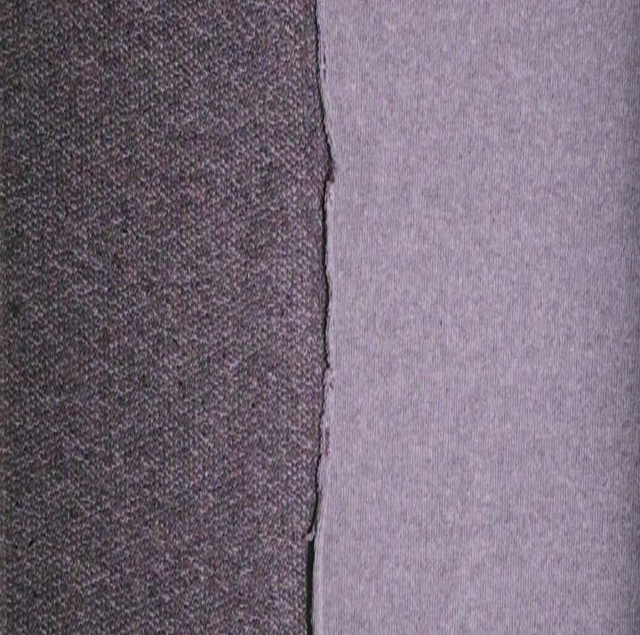
Figure 2a. Heavy jersey | Figure 2b. Linen jersey
Figure 2c. Denim | Figure 2d. Felt
Figure 2. Fabrics used to create digital samples

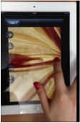 | 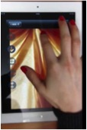
Figure 3a. Horizontal stroke | Figure 3b. Vertical stroke
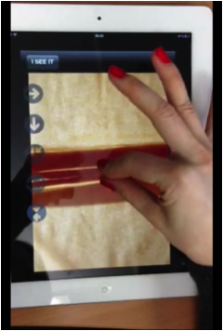 | 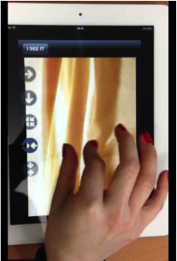
Figure 3c. Horizontal pinch | Figure 3d. Vertical pinch
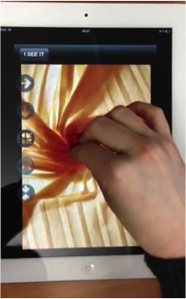
Figure 3e. Scrunch
Figure 3. Gestural interactions with digital samples thorough iShoogle

We explored three main themes through six questions (Table 3); the latter were displayed on a board and after engaging with the digital interactive videos of the fabrics, participants wrote down answers on sticky notes and attached them to the board. Each theme was given a broader focus, considering the overall aim of the study was to get a comprehensive understanding and scope the opportunities for digital tools developments. The theme regarding touch behaviour when interacting with fabrics has been investigated in greater depth in previous studies (Atkinson et al., 2013), focusing on consumers. Therefore in this study we chose a design (expert) community for comparison.
Table 3. Board questions
Theme | Question
Touch behaviour when interacting with fabrics | What type of gestures do you use when you interact with fabrics?
Quality, use and impact of technology on designers’ craft | Do you think digital samples could be a good way of communicating properties of fabrics?
 | What would the impact on your craft be, if sourcing materials were primarily digital?
 | How useful do you find digital databases for sourcing? Do you use them?
 | Do you think the way fabrics are shown online needs to be improved, and if so how?
Designers’ activities if technology was available to support fabric sourcing remotely | Would you minimise travelling to textile sourcing fairs if you could source more effectively online than is currently possible?

Analysis
All data was transcribed for analysis using the Thematic Analysis method, following Braun and Clarke’s (2006) guidelines. Coding was conducted using QSR International’s NVivo 10 software. The questions were used to guide the analysis, but focus was given to themes and sub-themes that emerged from responses, which are described in the results section.
Results
The results from activities 1 and 2 are reported separately in the following subsections.
Sourcing criteria and information needs
Participants’ responses to criteria for selecting fabrics (Table 4) are balanced between objective (functional) and subjective (experiential) characteristics of textiles. Other aspects such as cost and environmental issues are important, as indicated in previous research (Ashby and Johnson, 2010; Van Kersteren, 2008; Karana et al, 2008). Therefore, designers’ criteria when selecting materials previously identified in design research could be extrapolated for the fashion and textiles arena; however, this should be evaluated by further research to verify the impact of trends and culture on fashion designers’ decisions for textiles.
Table 5. Distribution of criteria used for selecting fabrics (clustered categories of objective and subjective criteria)

Number of participants | Frequency of choice
 | Objective criteria | Subjective criteria | Objective and/or subjective criteria
5 | 1 | 1 | 1
5 | 1 | 2 | 0
3 | 2 | 1 | 0
3 | 2 | 0 | 1
3* | 0 | 0 | 0
2 | 3 | 0 | 0
1 | 0 | 2 | 1
1 | 2 | 0 | 0
1 | 1 | 0 | 0
* No answer was provided
Table 4. Key criteria used for selecting fabrics (participants selected 3 options, 4 participants didn’t reply)
Number of participants | Criteria chosen
8 | Composition
6 | Properties of texture
6 | Aesthetic
6 | Fibre characteristics
5 | Application
5 | Cost
5 | Intention
5 | Pleasurable touch
4 | Other - sustainability
3 | Design brief
3 | Performance
3 | Sensory stimulation
1 | Intuition
3 | No answer was provided

Answers were distributed between criteria (Table 4) and remained inconclusive (the highest agreement was found with 8 out of 21 respondents), meriting further investigation. The least chosen options were ‘Intuition’ and ‘Enjoyment’, which are subjective and in contrast to the most selected option ‘Composition’. This early evidence seems to indicate that designers perceive their selection as more related to objective criteria. However, three (‘Properties of texture’, ‘Aesthetic’ and ‘Fibre characteristics’) out of the five most frequent criteria are characteristics of fabrics that are experienced through the senses; also, ‘Properties of texture’ is largely experienced through touch, although it can be objectively measured. When clustering criteria only as objective and subjective (categorisation in Table 1), further differences are noticed, with ‘objective criteria’ being selected 31 times, ‘subjective criteria’ selected 20 times and ‘objective and subjective’ selected 9 times. While verifying inter-personal differences to distribution criteria (Table 5), considering the clustered categories, it seems that most designers include a mix of objective and subjective criteria.
Table 6. Information sources used by designers when selecting fabrics (participants selected as many options as they judged applicable)
Number of participants | Information source
17 | Exhibitions
13 | Personal experience
13 | Supplier or manufacturer
12 | Sample collections
12 | Internet
12 | Tradeshows
10 | Books
8 | Museums
8 | Tests and experiments
7 | Example products
7 | Magazines
6 | Vintage shops
6 | Brochures
5 | Films
4 | Personal collection
4 | Databases
3 | Apps

The sources used for informing fabric selection (Table 6) are varied and extend beyond technical specifications and objective information into designers’ personal experience, cultural and market influences, reiterating findings from the literature (Van Kersteren, 2008; Bang, 2009) and relating to the concept of distributed knowledge. Most participants selected several options as information sources, which remains too general in terms of their information needs and the amount of information absorbed. Designers use a mixture of sources (Table 6) and responses show the importance of experience for sourcing – there is higher use of more experiential material (e.g. Sample collections, Example products), immersive and socially engaging environments (e.g. Exhibitions, Tradeshows, Vintage Shops) than reference material and data only (e.g. Internet, Books, Brochures and Databases).
Exploration of existing digital tool: opportunities and needs
The results obtained from the iShoogle experiment indicated four main themes: touch for fabric sourcing; when and how tools can be integrated to the process of fabric sourcing; designers’ needs; and limitations and opportunities for digital tools development. These are described using the notation P# to indicate participants’ anecdotal evidence.
Touch for fabric sourcing
Results show that the gestures designers used (Figure 4) partially overlap with those observed in consumers (Atkinson et al. 2013) but also includes some new gestures. Whilst the most frequent gestures (rub, stroke, pinch and scrunch) were observed also in non-experts consumers (Atkinson et al. 2013), fold, pull and drape seem to be more specialist gestures, which were only noticed in the study with designers herein reported.
Figure 4. Designers’ touch behaviour for exploring textiles.

Movement and feel
Participants considered that interactive videos provide a better idea of the fabric behaviour. “Gives a sense of drape qualities.” (P22)
They consider that digital samples could inform them about the movement and texture of fabrics, but still consider the manipulation of the actual fabric crucial for its appreciation. “To review texture and movement, yes. But it’s very important to touch for handfeel.” (P6).
Although participants provided brief answers, their understanding of ‘feel’ seems more related to sensory stimuli beyond their hand movement. This relates back to the definition by Philippe et al. (2003), which comprises both aspects. Overall, designers consider touching the textile a crucial step for their sourcing and believe that “The actual sampling will never go away completely.” (P11).
When and how tools can be integrated to fabric sourcing process
Initial filter or research tool
Participants consider interactive videos useful as a filter before traveling to textile fairs, declaring it a “Good starting point.” (P6), but they still need to touch for making final decisions. They mentioned a tool would be useful for the initial stage of design, during the research process when they have to come up with ideas of textiles, before checking what suppliers’ have to offer.
“For the research it would be really useful, at the start of the creative process.” (P5)
“You could filter samples down to your favourites.” (P14)
Additionally, they consider that interactive tools could provide more information about fabrics’ behaviour, which they are not familiar with. Participants suggested that it would be interesting to produce a set of reference fabrics with interactive videos to be used as sourcing tool, in which different classes of fabrics would be represented through a condensed archive. Thus, indicating opportunities for development of supporting tools for research and ideation stages.
Saving - time, space, money and travelling
Participants envisaged digital tools could be “Time saving.” (P6)], space saving [“… would be an interesting thing to replace big suitcase with an iPad.” (P3)], facilitate “Quicker development process. Also possibly money saving” (P19), besides considering it a more resilient format than the current textile samples provided by industries [“Definitely save time! (…) Efficient and durable.” (P24)], and still providing an experience through interaction [“Good to carry fabrics with you in a lighter and interactive way.” (P23)].
In relation to reducing travel to fairs, positive and negative responses were balanced. Those who would minimise traveling are based on the premise that digital tools would facilitate their sourcing activities [“Yes, sure. If it was more effective, I wouldn’t travel.” (P2)], but have reservations in relation to compromising the social side of fairs, where they have the chance to meet suppliers, colleagues and build networks. Some designers mentioned they “Would definitely still attend larger fairs.” (P19). Also, the need for samples to be provided remains (P4, P7).
Those who would still travel would welcome the inclusion of digital means to support their current activities. “I source from hundreds of mills based on conversations. So no, but it might streamline the trip and help plan.” (P8). “I find it important to meet people in the fair (producers), so I would like to see a combination of fair, but also being able to source online.” (P10).
Designers’ needs
Besides the “need to feel the fabrics, as it is a very important decision.” (P21) and to socialise at fairs, participants reported other needs, related to memory and communication within their projects. This can be in communication with suppliers [“Just talk to a supplier that responds to your needs. Useful.” (P11)], through personal and others’ previous experience that inform their selection process [“Feedback from other companies help, or previous experience. But if the contact is new, you need more samples.” (P4)], or making available “more images of fabric in use (as garment or draped)” (P19).
Furthermore, observations of designers’ behaviour highlighted that it is common practice to take pictures of exhibited fabrics, also registering their technical specifications (Figure 5) as samples generally cannot be taken and must be requested from suppliers by post. These factors indicate an opportunity for tools that support managing samples collected in fairs.
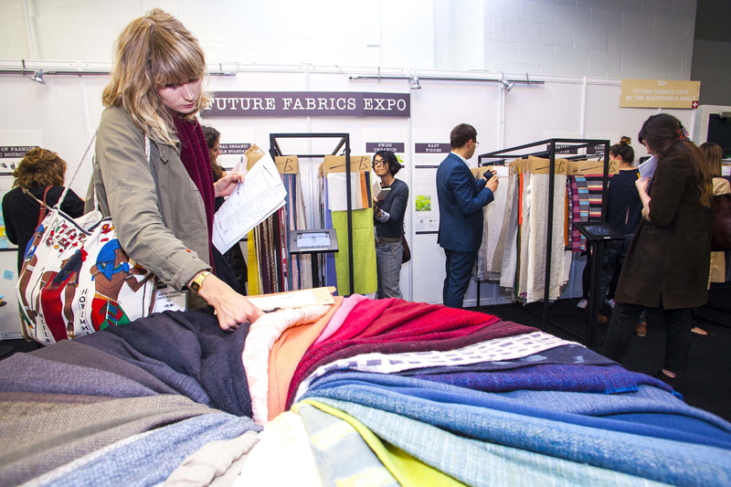
Figure 5. Visitors taking photos and making annotations. © The Sustainable Angle Photography Green Lens Studios 2013. Source: http://www.thesustainableangle.org/futurefabricsexpo/Photos/FutureFabricsExpo2013.aspx

Digital tools development
Limitations of the technology
Designers see interactive videos as a step ahead from the current online stills [“Gives more information than photos. Seems to be a good way to go… But how to give the textural information?” (P1)]. They would like to have more three-dimensional information and possibly related to a context of use. “It’s only shown flat. You can’t get the feeling from drape.” (P23).
They consider that interactive videos would be useful “especially for online e-retailers.” (P22), but still lack refinement for designers. Still, this demonstrates an opportunity for tools that support sourcing over distance providing an improvement on current experience.
Opportunities for improvement
Some participants clearly expressed their expectations from a tool such as iShoogle (Orzechowski, 2010) mostly relating to improvements to “see fabric in different situations and in different manipulations.” (P14). They also suggested additional features, such as magnifying and improving interactivity (P16) to support understanding of fabrics’ properties and agency (Repp and Knoblich, 2007). “Magnify / zoom. Stay once deformed. Connection between length of gesture and recovery.” (P17), or showing different aspects “Combine verbal and visual descriptions. Show close ups and on a person.” (P13).
Discussion and future work
This study was motivated by our research questions on (1) how designers source textiles and engage with them during this process, and (2) if and how digital tools could support designers in this activity. We reinforce that both the participants’ sample size and the sustainability context of FFE are limitations to this study and could have biased responses. Results of the study are herein summarised and should feed into inspiration and requirements for a digital tool:
- Designers consider touch imperative for experiencing textiles.
- Designers consider that a tool could make their sourcing process more efficient - time, space and moneywise.
- Designers believe a tool would be an addition to the selection process, but still need to see and feel fabric samples, interact and communicate with their stakeholders, and to share information about previous experience with suppliers and materials.
- Most participants selected a number of options as information sources. Research shows that different information sources are used at different stages of the design process (Van Kesteren, 2008; Karana et al, 2008), but we are still left with questions about how they organise, store and share this information, since their reports suggest that their own and others previous experiences are an important input for sourcing textiles.
Opportunities for development of digital tools
Research and ideation
Designers are interested in interactive video or broadly on digital tools that would support research, particularly in the early stages of material selection. If video-based, the tool ideally should convey three-dimensional and textural information, offer magnification and include a wider variety of manipulations, besides providing the basic technical specifications.
Sourcing over distance
Current tools and technology do not support articulation of designers’ perceptions or remote communication of textiles properties. In terms of the impact digital tools could have in their practice, designers see potential benefits in adding efficiency and better informing decisions, but still do not fully embrace the idea of minimising travelling to fairs, due to their social dimension. From this small study, it is inconclusive whether digital textile sourcing would help to reduce environmental impact related to travels and textile waste generated by physical sampling, though it may give designers the opportunity to make more informed decisions.
Sample management
The study indicates opportunities for technology development and reinforces the importance of using physical textile samples as ‘thinking tools’ in design (Kirsh, 2013), once they play a key role, as identified by most participants. As samples are unavailable immediately and designers would take pictures of the fabric and/or of the technical specifications, would it be helpful to have a way of producing a multimodal register that designers could take with them straight away?
Opportunities for alternative more experiential tools development
From the summary of results it is clear that designers want and need to better understand and communicate about sensory properties of textiles; this is an integral part of choosing textiles, and touching is the one single thing that no participant would remove from their fabric sourcing process. Sensory perception facilitates cognition; this is reinforced by designers’ need to feel the fabric as a crucial step for understanding and making decisions. This is aligned to the distributed knowledge and embodied cognition perspectives, and is also complemented by the view of Tallis (2003) that from tactile interaction people develop “tactile knowledge”, which “…is acquired serially (…) a cumulative understanding of the properties of individual objects”. Participants’ responses indicate that when experiencing a textile, one gets an understanding of it and of how it feels. The fair environment seems to be an “enactive landscape” where designers act “in a goal-oriented manner” (Kirsh, 2013), experiencing fabrics for selecting those suitable for their designs. Moreover, designers argue that the social side of fairs is important for sourcing, which from a distributed knowledge perspective potentially indicates that designers’ decisions are more a team activity (design team and stakeholders) than individual.
The results obtained from this study will inform the creation of new concept tools that will be tested at a future fair.
Acknowledgements
Thanks to our funders the National Council for Scientific and Technological Development (CNPq), Brazil and the European Regional Development Fund. Also thanks to Dr Penelope Watkins and Future Fabrics Expo for supporting the study.
References
Adobe Kuler. (2014) Retrieved January 21, 2014, from http://www.adobe.com/products/kuler.html
Allione, C, Buiatti, E., De Giorgi, C., Lerma, B. (2012) Sensory and sustainable strategies in the methodological approach to design. Proceedings of 8th International Design and Emotion Conference. Central Saint Martins College of Art & Design, 11-14 September. London.
Amaral, E., Bouchard, C., Kindlein Jr, W., Omhover, J-F. (2012) Evaluation des systemes physiques et virtuels d’interaction emotionnelle dans le contexte de la conception des produits. CONFERE 2012 Venice.
Ashby, M. and Johnson, K. (2003) The art of materials selection. Materials Today, 24-35.
Ashby, M. and Johnson, K. (2010) Materials and Design: The art and science of material selection in product design. Second edition. Butterworth-Heinemann, Oxford, UK.
Atkinson, D., Orzechowski, P., Petreca, B., Bianchi-Berthouze, N., Watkins, P., Baurley, S., Padilla, S., Chantler, M. (2013) Tactile perceptions of digital textiles: a design research approach. Proceedings CHI 2013.
Bang, A.L. (2007) Fabrics in function - emotional utility values. Design Inquiries. Stockholm. www.nordes.org
Bang, A. L. (2009). Facilitated Articulation of Implicit Knowledge in Textile Design. In K. Niedderer, L. Reilly, S. Roworth-Stokes, & C. Smith (Eds.), EKSIG 2009: Experiential Knowledge, Method and Methodology - International Conference 2009 of the DRS Special Interest Group on Experiential Knowledge, Conference Proceedings 2009, ISBN 0956278930.
Bang, A.L. (2011) Emotional value of applied textiles. PhD Thesis. Kolding School of Design.
Behery, H.M. (2005) Effect of mechanical and physical properties on fabric hand. Cambridge: Woodhead Publishing.
Bensaid, S.; Osselin, J-F.; Schacher, L. and Adolphe, D. (2006) The effect of pattern construction on the tactile feeling evaluated through sensory analysis. J Text Ins, 97(2), 137–145.
Bianchi-Berthouze, N. (2013) Understanding the role of body movement in player engagement. Human Computer Interaction, 2013.
Brandt, B., Brown, D.M., Burns, L.D., Cameron, B. A., Chandlerc, J., Dallasa, M. J., Kaiserc, S. B., Lennone, S. J., Panc, N., Salussof, C. and Smitleyg, R. (1998) Development of an interdisciplinary method for the study of fabric perception. J Text Ins 89(1).
Braun, V. and Clarke, V. (2006) Using thematic analysis in psychology. Qualitative Research in Psychology, 3(2), 77-101.
British Fashion Council (2009) Value of fashion report. Retrieved January 21, 2014 from http://www.britishfashioncouncil.co.uk/content.aspx?CategoryID=1745
Ciesielska-Wróbel, I.L., Van Langenhove, L. (2012) The hand of textiles – definitions, achievements, perspectives – a review. Textile Research Journal, 82(14), 1457-1468.
Cho, G., Kim, C. and Casali, J.G. (2002) Sensory Evaluation of Fabric Touch by Free Modulus Magnitude Estimation. Fibers and Polymers, 3(4), 169-173.
Design Council description of the Double Diamond. (2005) Retrieved January 21, 2014 from http://www.designcouncil.org.uk/about-design/How-designers-work/The-design-process/
Dillon, P., Moody, W., Bartlett, R. et al. (2000) Sensing the Fabric: to simulate sensation through sensory evaluation and in response to standard acceptable properties of specific materials when viewed as a digital image. Haptic HCI. Springer, pp. 63-68.
Dormer, P. (2007) The culture of craft. Manchester University Press.
Fashion SVP. (2014) Retrieved January 21, 2014, from http://www.fashionsvp.com/
Guest, S. and Spence, C. (2003) What role does multisensory integration play in the visuotactile perception of texture? International Journal of Psychophysiology, 50, 63–80.
Howorth, W.S. and Oliver, P.H. (1958) The application of multiple factor analysis to the assessment of fabric handle. Journal Text Ins, 49.
Jenkins, G & Lamb, J. (1987) FabricWise: fabric choice for people with disabilities. The Disabled Living Foundation.
Jordan, P.W. (2008) The four pleasures: understanding users holistically. In: Proceedings of Applied Ergonomics International.
Karana, E. (2009) Meanings of materials. PhD Thesis. Technische Universiteit Delft.
Karana, E., Hekkert, P. and Kandachar, P. (2008) Material considerations in product design: A survey on crucial material aspects used by product designers. Materials and Design, 29(6), 1081-1089.
Karana, E., Hekkert, P. and Kandachar, P. (2009) Meanings of materials through sensorial properties and manufacturing processes. Materials and Design, 30(7), 2778-2784.
Karana, E., Hekkert, P. and Kandachar, P. (2010) A tool for meaning driven materials selection. Materials and Design, 31, 2932-2941.
Karana, E., Pedgley, O. and Rognoli, V. (2013) Materials experience: fundamentals of materials and design. Elsevier.
Kawabata, S. (1982) The development of the objective measurement of fabric handle. In: Kawabata, S.; Postle, r.; Niwa, M. Objective specification of fabric quality, mechanical properties and performance. Osaka: Textile Machinery Society of Japan, p.31-59.
Kirsh, D. (2013) Embodied cognition and the magical future of interaction design. ACM Transactions on Computer-Human Interaction (TOCHI), 20(1), 1-30.
Laughlin, J. (1991) Perception of Fabrics: A Texturalcentric study of the visual and tactile responses of adult and elderly women. International Journal of Clothing Science and Technology, 3(5), 20-31.
Le Laboratoire. Retrieved January 21, 2014, from http://lelaboratoire.org/CP%20Olfactive%20Project%20ENG%2013.04.09.pdf
Lee, C.P. (2007) Boundary Negotiating Artifacts: Unbinding the Routine of Boundary Objects and Embracing Chaos in Collaborative Work. Computer Supported Cooperative Work, 16 (3): 307–339. doi:10.1007/1-4020-4023-7_20
Lee, H., Kim, J. and Fiore, A.M. (2010) Affective and Cognitive Online Shopping Experience. Clothing and Textiles Research Journal 28 (2): 140-154.
Magnenat-Thalmann, N., Bonanni, U. (2008) Haptic sensing of virtual textiles. In: Grunwald, M. Ed. Human Haptic Perception: Basics and Applications. Birkhauser, pp. 513-523.
Mani, P., Søresen, N.J., Cutcliffe, D., Peña, J., Andersen, M.B. (2013) DAMADEI: Design and Advanced Materials As a Driver of European Innovation. European Union. ISBN: 87-90904-67-2. Retrieved April 20, 2014, from http://www.damadei.eu/report/
Merleau-Ponty, M. (2002). Phenomenology of Perception. Routledge, London, UK.
Miodownik, M.A. (2007) Toward designing new sensoaesthetic materials. Pure Appl. Chem., 79(10), 1635-1641.
Newman, D. That Squiggle of the Design Process, Central Design. Retrieved January 21, 2014, from http://v2.centralstory.com/about/squiggle/
NVivo qualitative data analysis software; QSR International Pty Ltd. Version 10, 2012.
Orzechowski, P.M. (2010) Interactive mobile presentation of textiles. Mobile HCI’10. ACM, pp.477-478.
Park, Y., Baek, K., Nam, T. (2013) The Roles of Touch during Phone Conversations: Long-Distance Couples’ Use of POKE in Their Homes. Proceedings CHI 2013.
Peck, J., and Wiggins, J. (2006) It just feels good: Customers’ affective response to touch and its influence on persuasion. Journal of Marketing 70(4), 56-69. doi:10.1509/jmkg.70.4.56
Pedgley, O. (2009) Influence of Stakeholders on Industrial Design Materials and Manufacturing Selection. International Journal of Design, 3(1), 1-15
Pantone Capsure. (2014) Retrieved January 21, 2014, from http://www.pantone.co.uk/pages/products/product.aspx?pid=1433&ca=7
Petreca, B., Bianchi-Bertouze, N., Baurley, S., Watkins, P., Atkinson, D. (2013) An embodiment perspective of affective touch behaviour in experiencing digital textiles. Proceedings ACII 2013.
Philippe, F., Schacher, L., Adolphe, D.C., Dacremont, C. (2003) The sensory panel applied to textile goods - a new marketing tool. JFMM, 7(3), 235-248.
Philpott, M. and Summers, I.R. (2012) Evaluating a Multipoint Tactile Renderer for Virtual Textured Surfaces. Springer, pp. 121-126.
Repp, B. H., Knoblich, G. (2007). Toward a psychophysics of agency Detecting gain and loos of control over auditory action effects. Journal of Experimental Psychology: Human Perception and Performance, 33(2), 469-482.
Rognoli, V. (2010) A broad survey on expressive-sensorial characterisation of materials for design education. METU Journal of the Faculty of Architecture, 27(2), 287-300.
Tallis, R. (2003) The hand: A Philosophical Inquiry into Human Being. Edinburgh University Press.
The Sustainable Angle. (2014) Retrieved January 21, 2014, from http://www.thesustainableangle.org/
Van Kesteren, I.E.H. (2008) Product designers' information needs in materials selection. Materials and Design, 29(1), 133-145.
Van Kesteren, I. (2010). A user-centred materials selection approach for product designers. METU Journal of the Faculty of Architecture, 27(2), 321-338.
Wu, D.; Wu, T.; Singh, H.; Padilla, S.; Atkinson, D.; Bianchi-Berthouze, N.; Chantler, M.; Baurley, S. (2011) The Affective experience of handling digital fabrics: Tactile and visual cross-modal effects. Springer LNCS 6974, pp.427-436.

In 2009 overall industry contributions to United Kingdom economy were expected to achieve £20.9 billion (British Fashion Council, 2009).
Retrieved in January 21, 2014 from http://www.pantone.co.uk/pages/products/product.aspx?pid=1433&ca=7
Retrieved in January 21, 2014 from http://www.adobe.com/products/kuler.html
Retrieved in January 21, 2014 from http://lelaboratoire.org/CP%20Olfactive%20Project%20ENG%2013.04.09.pdf
The Sustainable Angle are a not for profit organisation which supports fashion companies to make informed decisions around sustainability. Information retrieved in January 21, 2014, from http://www.thesustainableangle.org/
This is a fashion-sourcing event in the United Kingdom for buying directly from manufacturers. Information retrieved in January 21, 2014 from http://www.fashionsvp.com

