Written evidence submitted by Dr Kate Goldsworthy, Senior Research Fellow in Sustainable Textile Design & Technology, Textile Futures Research Centre, University of the Arts London.

The case for transforming the approach to waste, and growing a ‘circular economy’. A design perspective.

- The reality of designing for a circular economy presents the designer with many new challenges. In order to consider a products eventual incorporation back into the materials pool, the designer must understand the processes at end-of-life and create products which are designed to be recycled through those processes.
- ‘Recycling by itself, only postpones the arrival of the discarded material to landfill, where it may never biodegrade, may degrade very slowly, or may add harmful materials to the environment as it breaks down.’ A genuinely sustainable future depends on creating closed-loops, ‘where materials would never lose their value and would recycle indefinitely’ (Livingstone, 2003).
- At present, many design approaches to recycling are ‘reactive’ as they attempt to work with existing waste streams at the point of disposal.
- On the journey from raw material to product, previously recyclable resources are often inextricably fused together to create material mixes or ‘monstrous hybrids’ as coined by McDonough and Braungart (2002), and this prevents efficient and economic materials recovery.
- Designers need to adopt a more ‘pro-active’, systems-based approach that truly ‘closes the loop’. In order to design fully recyclable textile products, potential barriers to recycling should be identified and ‘designed out’ at the production stage.
- Although pro-active strategies are a key area for designers to develop, re-active approaches will continue to be needed to address the waste already in the system. More research into technologies which can separate blended materials at end-of-life is needed in order to ‘rescue’ more valuable materials from landfill.
- There is much confusion between ‘mechanical’ recycling (i.e. the recycling of PET bottles into fleece) and full ‘chemical’ recycling processes (i.e. Teijin’s Ecocircle process). The later results in virgin quality materials time after time, whilst the former degrades with each subsequent recycling. Only full material recovery is a viable option for recycling of materials over the long-term. All other processes simply extend life.
- The ‘hierarchy of recycling options’ (Gertsakis & Lewis, 2003) states that the further back around a products lifecycle journey the recycling process extends the more energy is used in that transformation, however, as the energy required increases, the value of the resulting material can also be seen to increase. Therefore ultimately the only truly sustainable option is full chemical recycling (back to raw materials). Other options, although less energy intensive, offer fewer environmental savings and ultimately material value is lost.
- One of the main challenges is the need to engage the consumer and change their waste disposal patterns, but there are also new business opportunities in remanufacturing that make this economically attractive.
- The only way to retain material value in all future recycling journeys is to create ‘closed loops’ of material recovery where the inherent value of materials are retained for unlimited future lifetimes. These cradle to cradle processes return materials to their raw chemical components which can then be rebuilt (or grown) into new materials without ever losing quality.
- The best example of this is nature’s own process, Biodegradation, whereby biological nutrients are returned to a form which can support new growth thus completing the cycle. In our man-made material world the closest we have to this is chemical Repolymerisation where technical nutrients are returned to manufacturing systems for the production of brand new materials.
- Avoided environmental impacts with this approach are the most impressive: impacts of manufacturing virgin materials (materials, energy, emissions, wastes), landfill impacts (air emissions, leachate, visual impact), impacts of fertiliser and pesticide manufacture (materials, energy, emissions, wastes, water conservation), carbon sequestered in land or reprocessed into new polymers. There are also environmental impacts to be considered in the transport (use of fuels, air emissions) and chemical processes used (materials, energy, emissions, wastes).
- New business opportunities lie in composting services or the repolymerisation industry, where there is currently a large amount of activity around innovations in chemically recycling mixed-fibre materials for closed-loop systems.
- All except full chemical-recycling processes cause materials to be ‘downcycled’ with each reincarnation until eventually they end up as landfill. It is for this reason that re-active approaches, alone cannot provide a lasting solution for our finite materials.
- The diagram below illustrates these recycling and recovery options for textile materials. Where the cycle fades along its path this represents a decreasing material value during recycling. This will always be the case unless the material goes through a process of ‘recovery’ which returns it to virgin quality raw materials (the outer circle) which can be repeated endlessly. As shown below this is the only path which ensures retained material value.
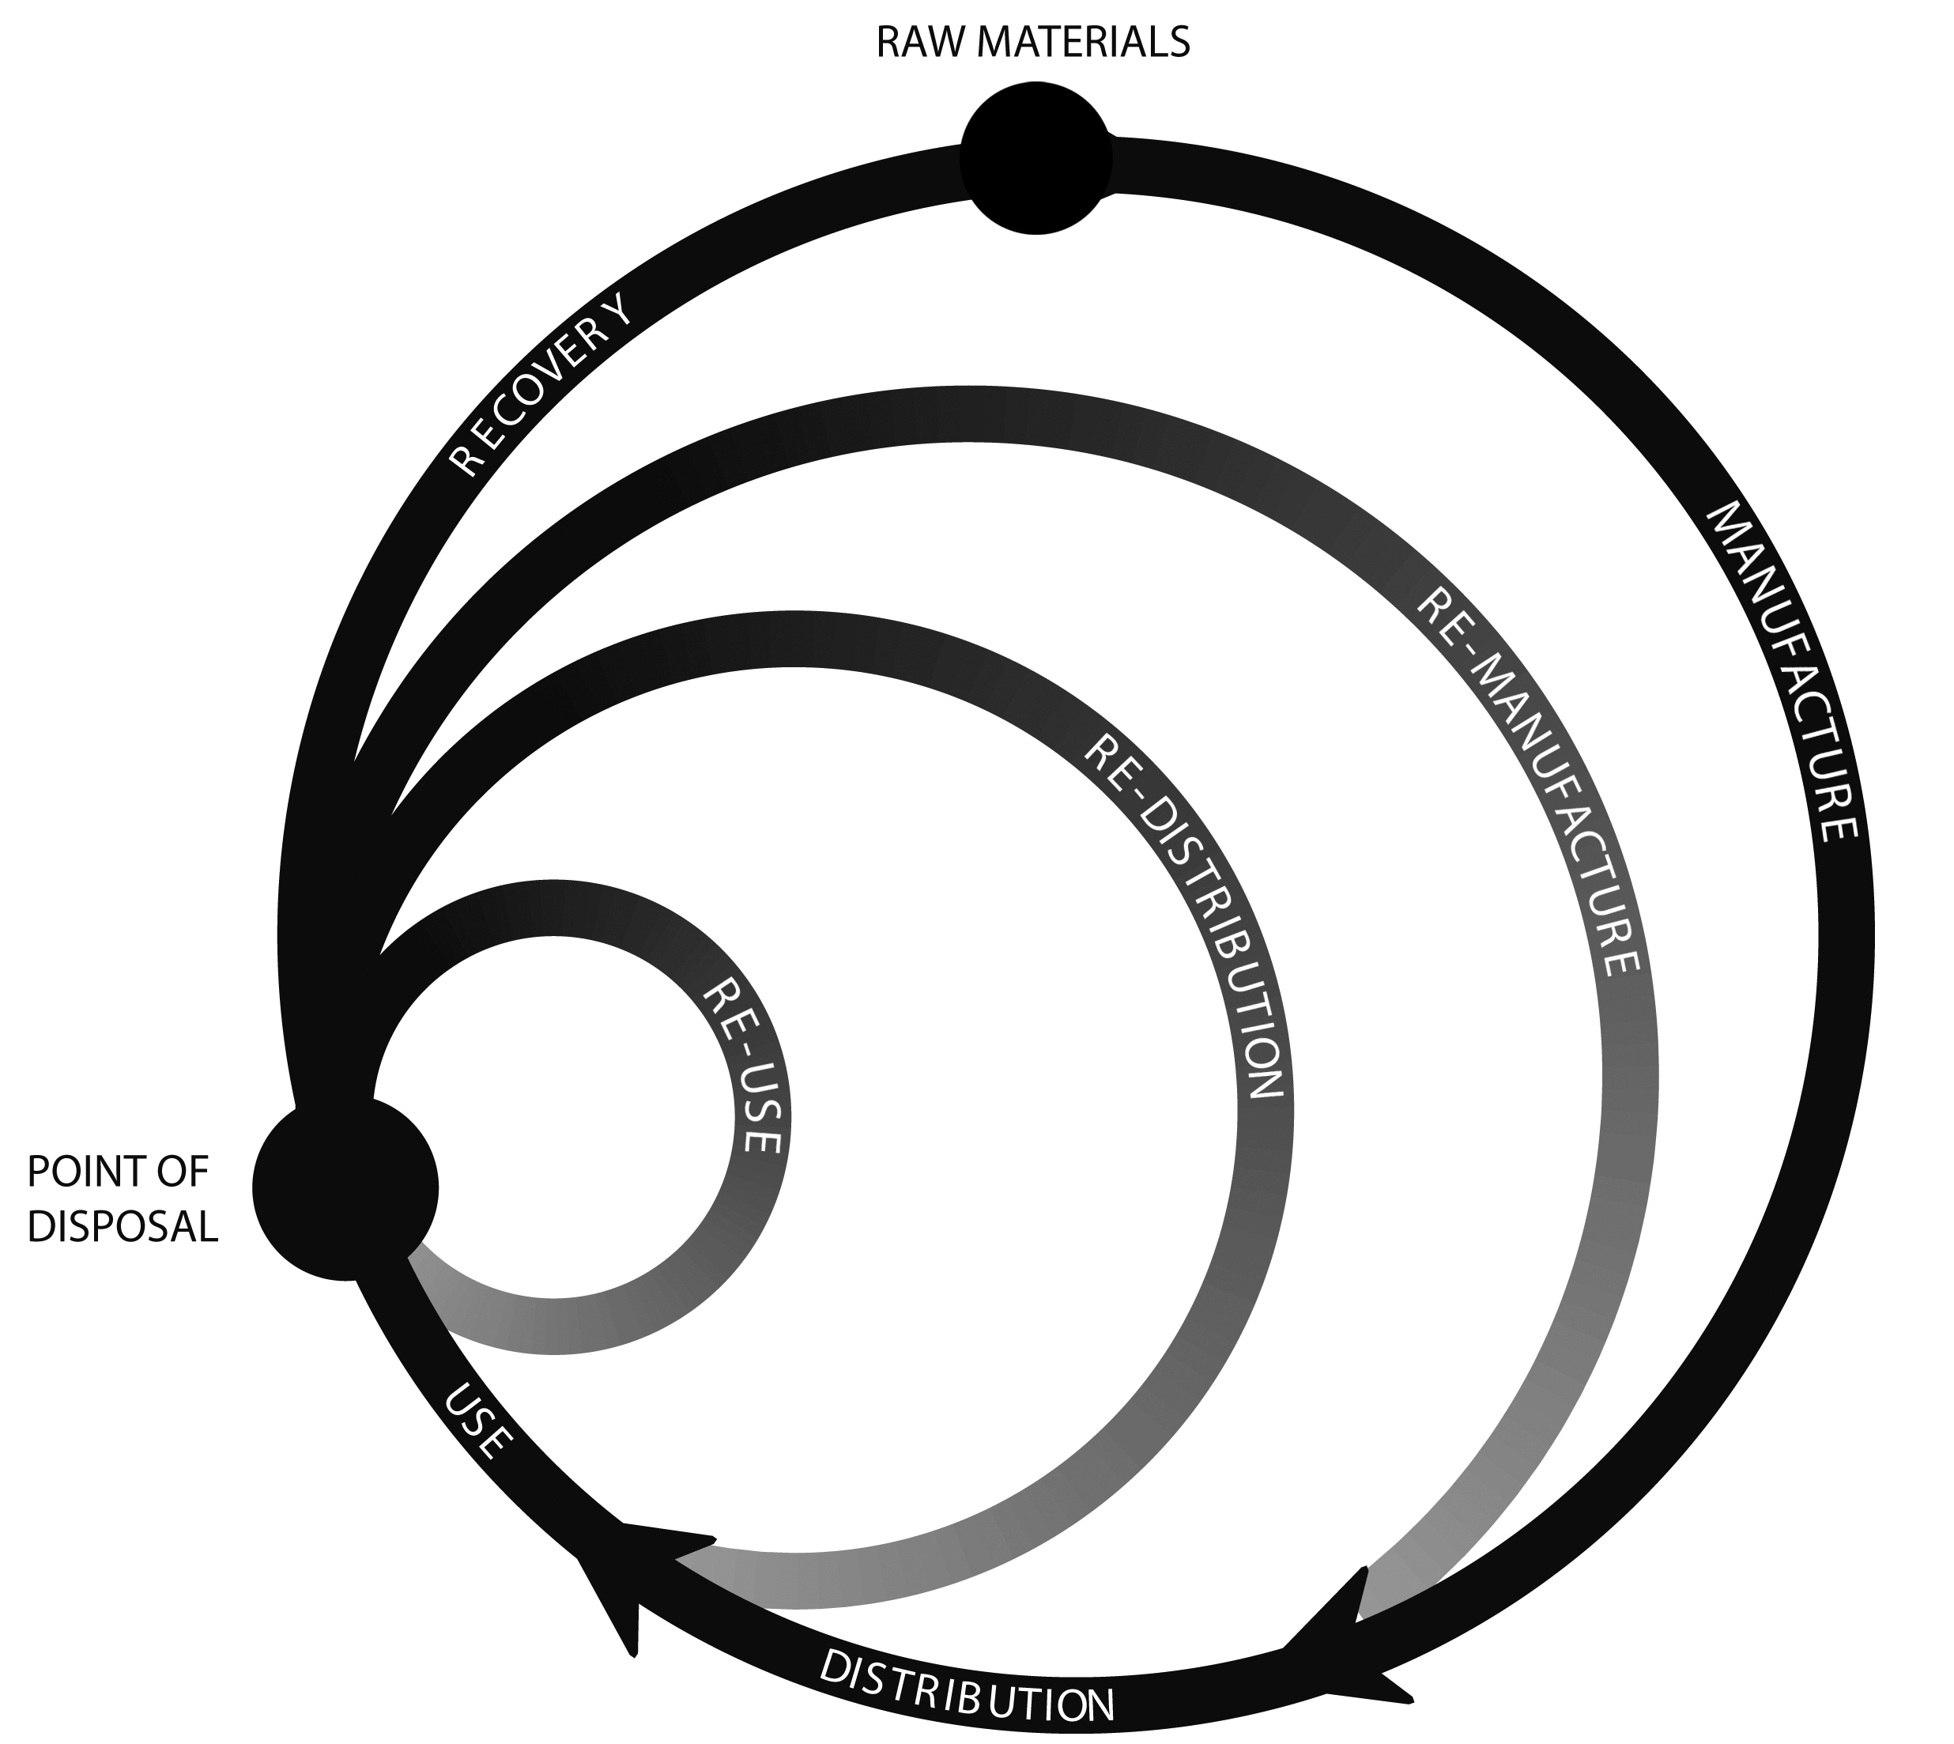

- Reference: Goldsworthy, K. (2014), Design for Cyclability: Pro-active approaches for maximising material recovery, Making Futures. Vol 3. ISSN 2042-1664 Available at http://makingfutures.plymouthart.ac.uk/mf3.php?pageID=12

