“The Crivelli’s New Reading”

An Erasmus Intensive Programme instigated by colleagues at the
Accademia Belle Arti, Macerata, Italy,
Professor + Project Leader – Teresa Marasca, Eleonora Sarti
in partnership with -

University of Art and Design of Cluj-Napoca, Romania
Key Participant – Istvan Kudor-Duka

Central Saint Martins College of Arts and Design
University of the Arts London, UK
Key Participant – Stephen Carter

Dates From 9.9.2013 – 23.9.2013

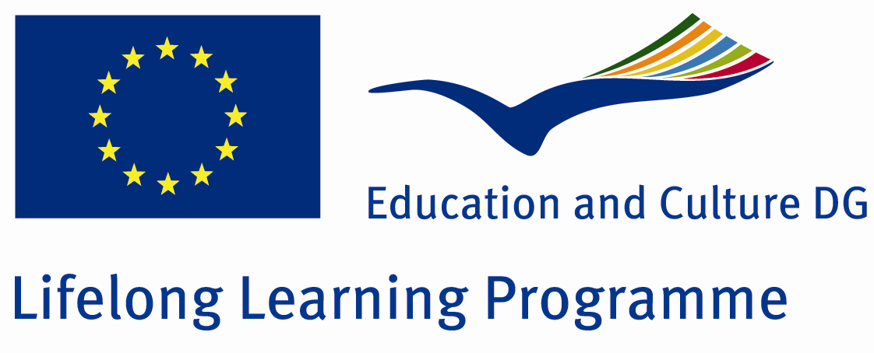
The Crivelli’s painting in the context of European Art
This programme was initiated by Teresa Marasca, artist and lecturer at Macerata Fine Arts Academy, Italy and also included participation with the University of Art & Design, Cluj-Napoca Romania. It is supported by and receiving funds from the European Union Erasmus Lifelong Learning Programme scheme.
The project focused on the reinterpretation of the work of the Crivelli brothers (Vittore & Carlo Crivelli) (active around 1470).
Within this time the group studied the Crivelli’s paintings in Monte San Martino, made work, attended workshops, lectures and discussion groups.
The project culminated in an exhibition “For a New Reading Crivelli” at the City Art Gallery in Monte San Martino. All participants donated a work made on the project to the permanent collection of the Pinacoteca Civica, Monte San Martino.

