Susanna Round

‘Satellite dishes are wonderful!’

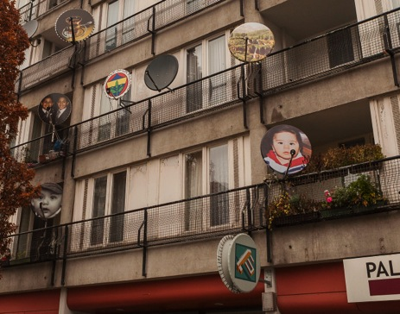
Project by Daniel Knipping, The Pallasseum, Berlin, photograph by David Mollander

The question of what happens to buildings after they are built is an often-neglected area of architectural thinking. The work of architects is usually represented by an image from the moment of completion, as though it’s future habitation is not relevant. There is an unquestioning orthodoxy when discussing buildings, of ‘the original’ as some idealized state to strive towards. Additions to buildings are often seen as an ‘annoyance to the architect’ (clickclickjim: 2014) rather than considered as something that might have value in itself.

For this research I take my cue from the moment when the users inhabit the spaces in and around buildings, and start to play a role in their on-going life. Using de Certeau’s framework of placing value on everyday activities and Lefebvre’s notion of spatial production, I will investigate a number of ways in which users physically change their environments through DIY, adaption and modification as well as the social life of buildings – the way that buildings are transformed by the activities that take place within them.

Using examples from buildings of the 1960’s and 70’s, I approach this architectural debate via my practice as an artist. This involves engaging and working with people and situations as well as developing the debate via constructions, imagery and installations.

Comment made by the architect of Neue Kreuzburg Centrum, Berlin, when asked what he thought about the 60’s housing development in the present, at Failed Architecture workshop, November 2012.
Charles Holland develops this argument in the Radical Post-Modernism issue of Architectural Design, 2011.

