ain’t no mountain high enough
ain’t no valley low enough
ain’t no fjord wide enough
to keep us from
getting to you
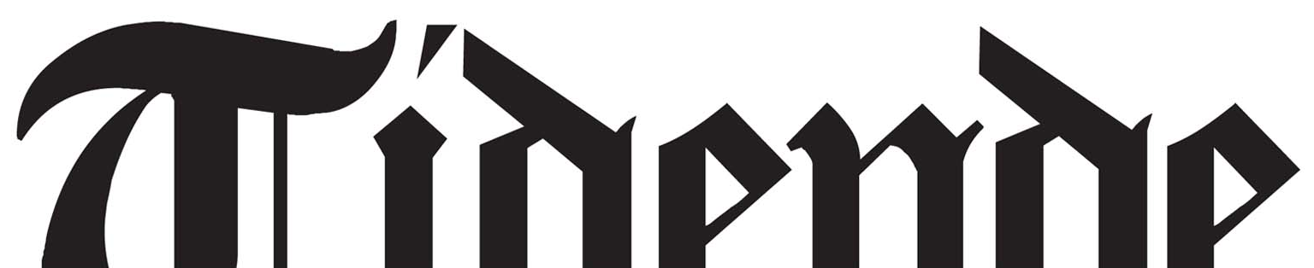

Sogn og Fjordane Kunstmuseum is opening a new museum of Contemporary Art and the news is being spread via the publication you now are holding in your hands; Kome til deg i Tidende (Getting to you Tidende).

Working collaboratively with artists and writers the two issues of Kome til deg i Tidende mark the lead-up to the museum’s opening September 8th 2012. Arriving on the doorstep of all homes in the region this project hopes to develop new ways to connect the museum to fresh possibilities both in Sogn og Fjordane and across the world.

In wishing to find new ways to explore the region, it’s context and it’s meaning Kome til deg i Tidende uses the mosaic form of a newspaper to reveal and exhibit new histories, urgencies and relationships that we believe are important. Kome til deg i Tidende is an experiment: we feel an art project arriving on your doorstep is a valuable way to examine our searching, playful exploration of two fundamental questions and propositions - What is the News?, and Why are you here?
What is the News? is a question that carries a great sense of urgency but this often depends on your point of view; the issues important to you, your community or your region. The space a newspaper gives to news articles reflects an editor’s sense of what readers should find important, so what if all aspects of the news were treated with equal urgency, we thought. Kome til deg i Tidende responds to this by creating a paper consisting of front pages only. Artists and writers have responded to our question What is the News? so that a wide span of urgencies and stories are brought to you in our first issue. The use of front-page gives a heightened or distilled version of the news, and stories being told in this issue will unfold further our next issue called Why are you here?
In this issue Georg Arnestad declares the new Sogn og Fjordane museum will be “An Art Museum for its Time”, offering a powerful symbolic make-over for the region as the site of an old dairy cooperative is transformed into a new glittering museum. But, he goes on to warn, one that will have to manage the delicate balance between being “an impetus and inspiration” for local artists and audiences as well as an international context. In another article Hans Jakob Reite writes that Sogn og Fjordane can be compared to “a little village in the big world” and that placing the county within a global perspective is an essential act, to which art and pondering are useful. His words are a reminder that the global perspective of any remote or small place is constantly interacting with the large world in all its complexities – through trade and commerce, but also through cultural exchange and its people.
Kome til deg i Tidende is an attempt to respond to and ponder that complexity through our many local, national and international contributors, all telling stories and histories from different part of the world and from a variety of viewpoints. Kome til deg i Tidende conveys stories that reflect diversity as opposed to homogeneity. We hope What is the News? will bring you surprising perspectives on what needs to be known for the common good.
Anne-Marie Creamer, Kjetil Berge and Lars Sture

